**Futsal Management System**

Roshan Lamichhane, Rahul Poddar, Nirajan Bhattarai, Rishan Shrestha, Binju Rai

Bsc.(Hons.) Computing, Softwarica College of IT and E-commerce, Coventry University

ST4008CEM Computing Activity LED Learning Project 2

Albert Maharjan

January 30, 2023

Table of Contents

Introduction 7

Keywords 8

Aim 9

Objectives 9

Problem Statement 10

Problem 10

Solution 10

Functionalities 11

Functional Requirements 11

Non-Functional Requirements 12

Literature Review 14

Development Methodology 16

Agile 16

Why use Agile Methodology 17

Tools and Technologies 19

Conceptual Diagram 21

System Architecture 22

Three Tier Architecture 22

MVC Pattern 23

Working Mechanism 25

Project Plan 27

Task Management 27

Release Plan 28

Gantt chart 29

Prototype 30

Low Fedility 30

High Fedility 36

Developed System 43

Outcome 50

Sprint 1 50

Sprint 2 51

Sprint 3 52

Sprint 4 53

Sprint 5 54

Testing 55

Conclusion 59

SWOT Analysis 60

Appendix 61

Version Control (GitHub): 61

Prototype (Figma): 61

Project Artifacts: 61

YouTube: 61

References 62

**Table of Figures**

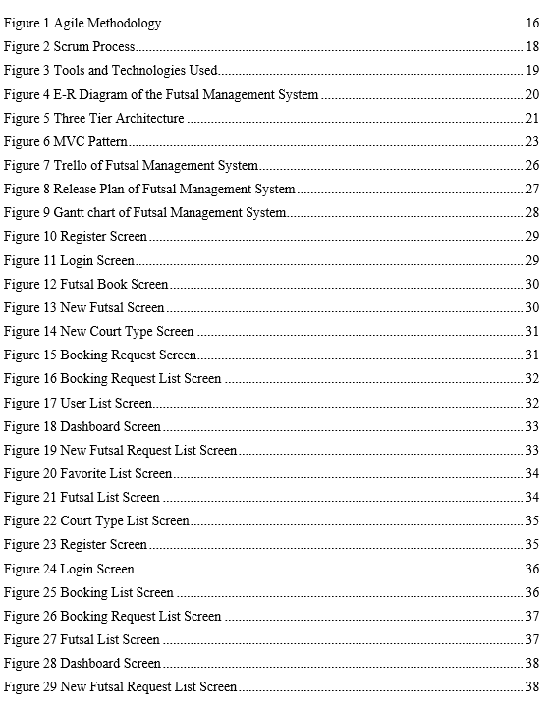

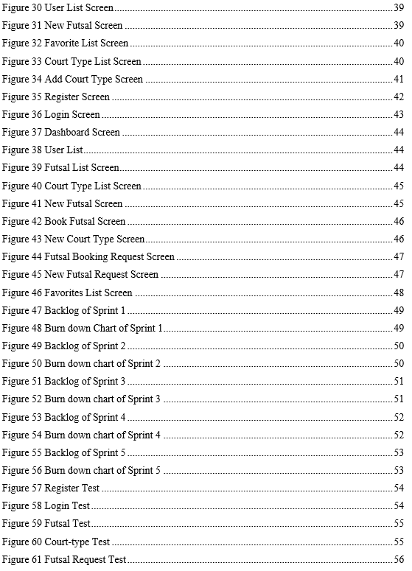

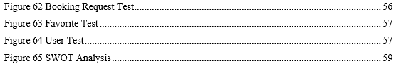

# Introduction

Introducing the Futsal Management Application, a revolutionary solution that redefines the way futsal enthusiasts engage with their favorite sport. Our user-centric app simplifies the process of discovering, reserving, and managing futsal venues, all while keeping users informed about their booking history. Designed with both users and administrators in mind, our application offers a comprehensive suite of tools for efficient management. Administrators can effortlessly handle booking requests, expedite the approval process for new futsal venues, and meticulously maintain detailed records. Futsal application imagines a consistent combination of enthusiasm and productivity, making an energetic local area where the affection for futsal flourishes.

Join us as we revolutionize the futsal experience by bringing fans and administrators together on one platform. The Futsal Management App is more than just a program; it opens the door to a future where futsal fans can enjoy unparalleled convenience and administrators can optimize their operations for a management process that is more effective and well-organized. Go along with us at the crossing point of enthusiasm and innovation, where the round of futsal becomes the overwhelming focus more than ever.

## Keywords

* Management System
* Futsal Venue
* Favorites
* Booking
* Booking Verification
* Agile
* Organized
* Futsal Request
* User Friendly
* Record Keeping
* Registration

# Aim

The aim of our project is to develop an innovative and comprehensive solution that seamlessly connects futsal enthusiasts with facility administrators and simplify the futsal experience for users by providing an intuitive platform to discover, book, and manage futsal venues.

# Objectives

* To implement a workflow for users to request the addition of new futsal venues to the platform.
* To provide administrators to review and approve these requests, ensuring the continuous growth of the app's venue database.
* To let users easily view and control their futsal-related actions over time, we provide a detailed and clear booking history feature.
* To provide administrators for verification and response to booking requests, including options for acceptance or rejection.
* To provide intuitive interface for users to easily browse and explore a list of futsal venues.

# Problem Statement

## Problem

In the current scenario of futsal management systems, enthusiasts and facility managers face many challenges that hinder the optimal utilization of available resources. Users often deal with fragmented information role when searching for suitable soccer venues, they face challenges to navigate through separate meetings to verify availability, timing and registration process gets burdened with shale equipment, with the cause of communication gap is facility poor management. Existing systems lack a unified and user-friendly interface that effectively integrates the needs of football enthusiasts and facility managers emphasizing the urgent need for a solution emphasizing comprehensiveness and simplicity. Our business goals are to address these deficiencies, a new Futsal Management App is provided to address these gaps and enhance the overall football experience users and managers.

## Solution

To address the current challenges in football management, we launched an innovative Futsal Management App designed to transform the user experience for enthusiasts and office managers alike. This new solution eliminates fragmented site searches, simplifies the authentication process, reduces the burden of the registration process caused by different tools and methods, and the app boasts connectivity unified and user-friendly, ensuring effective integration of user and facility manager needs. Prioritizing comprehensive and flexible solutions our objectives is to overcome issues of poor records, lack of stakeholder focuses and communication gaps Futsal Management App. We are ready to provide systems improve internal conflicts prevent abuse of resources, and enhance the overall experience for users and management.

# Functionalities

## Functional Requirements

* Authentication and Registration:

Creating accounts and log in security ensuring a personalized experience is given within the futsal management app.

* Futsal Venues:

Information about available futsal venues including details like location and facilities are provided for the users.

* New Futsal Request:

The users can submit requests for new futsal venues to the admin.

* Futsal Booking:

Enables users to browse book futsal venues, and receive instant confirmations, streamlining the booking process.

* Favorites:

Users can save their preferable futsal venues for quick and easy access, enhancing user convenience and personalizing the experience of the app.

* Booking History:

Futsal records of previously booked games are shown, which will help users track their usage history and make it easier to clearly display for future bookings.

* User Management:

It empowers users to manage their profiles, including personal information, preferences, and account settings, to ensure a personalized experience.

* Futsal management:

It provides management tools for administrators, allowing them to manage and update venue information, view booking analytics, and optimize facility operations.

## Non-Functional Requirements

Non-functional requirements are the set of specifications that describe the system's operation capabilities and constraints. These are basically the requirements that outline how well it operates, including things like speed, security, reliability, performance, etc

* Reliability:

Reliability encompasses the system's ability to consistently perform its intended functions without failure. Users rely on a reliable system to consistently deliver results and maintain functionality.

* Security:

Security entails protecting a system against unauthorized access, harmful attacks, and data breaches. Security measures include authentication protocols for verifying user identities, authorization mechanisms to manage access levels, and encryption to safeguard sensitive information, and methods to ensure data integrity. A secure system instills trust and safeguards valuable assets from potential threats.

* Scalability:

Scalability is a critical consideration as systems need to adapt to changing demands. Scalability can be achieved through horizontal scaling, where additional resources are added, or vertical scaling, which involves enhancing the capacity of existing resources. This ensures that a system can grow to meet the evolving needs of users without compromising performance.

* Performance:

Performance is a key determinant of user satisfaction. It encompasses the speed, responsiveness, and efficiency of a system under different conditions. A well-performing system contributes to a positive user experience and efficient business operations.

* Usability:

A system's success is not solely based on its features; it must also be user-friendly. Usability focuses on how easily users can interact with and navigate the system to achieve their goals. A system that prioritizes usability enhances user satisfaction, reduces errors, and promotes overall user adoption.

# Literature Review

This literature review aims to explore existing research and publications relevant to the development of a mobile application for booking futsal courts. The review will focus on identifying key findings and trends related to user needs, existing solutions, and potential challenges in the market.

1. **User Needs and Preferences**

Understanding the needs and preferences of futsal players is crucial for developing a successful booking app. Several studies have investigated user behavior and motivations regarding booking sports facilities.

* Convenience: Users prioritize ease of booking and access to information about futsal courts.
* Flexibility: Users desire flexible booking options, including last-minute booking and cancellation policies.
* Filters and Reviews: Users seek filtering options based on location, availability, price, and user reviews.
* Social Interaction: Users might appreciate features like connecting with other players or creating teams.

1. **Existing Solutions and Market Analysis**

Several futsal booking apps are available in the market, offering various features and functionalities.

* Features: Popular features include online booking, court availability, user profiles, booking history, and push notifications.
* Market Growth: The futsal booking market is expected to grow significantly in the coming years.
* Competition: Existing competitors offer different value propositions and target diverse audience segments.

1. **Challenges and Opportunities**

Developing a successful futsal booking app requires careful consideration of potential challenges and opportunities.

* Competition: Differentiation from existing players is crucial for capturing market share.
* User Adoption: Effective marketing and user acquisition strategies are necessary.
* Technology Integration: It's crucial to plan thoroughly when integrating with payment gateways and other services.
* Security and Privacy: Prioritizing the security and privacy of user data is of utmost importance.

# Development Methodology

## Agile

Agile software processes is an iterative and incremental based development, where requirements are changeable according to customer needs. It helps in adaptive planning, iterative development and time boxing. (javatpoint, n.d.) The agile process includes requirements gathering, analysis, design, coding, testing and delivers partially implemented software and waits for the customer feedback. In the whole process, customer satisfaction is at highest priority with faster development time. (Sharma, Gupta, & Sarkar, 2012)

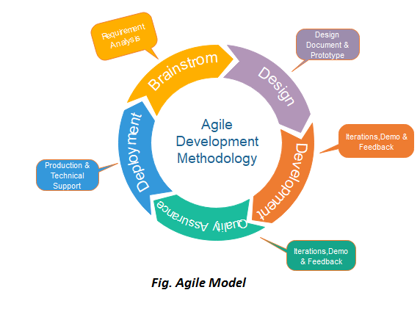

Figure 1 Agile Methodology

Why use Agile Methodology? (Darrell Rigby, 2016)

1. Adaptability to Change:

Agile embraces early and frequent releases, enabling you to test features and gather user feedback quickly, iterating and improving the app with each sprint.

1. Faster Time to Market:

As agile process is iterative in nature, it requires the time limits on each module with respective cycle (Sharma, Gupta, & Sarkar, 2012). Continuous testing and feedback during development cycles help identify and fix issues early, preventing costly delays and rework in later stages.

1. Enhanced Collaboration and Visibility:

As agile process is modular in nature, it needs a good communication among software development team. Different modules need to be integrated at the end of the software development process (Sharma, Gupta, & Sarkar, 2012).

1. Improved Quality and Control:

Agile's iterative approach allows for continuous testing and improvement throughout the development process, leading to a higher quality app with fewer bugs. The focus on small, manageable tasks facilitates better control over the development process, allowing for quick adjustments and risk mitigation.

1. Reduced Risk and Cost:

Agile's emphasis on early delivery and user feedback helps identify and address potential issues early, reducing the risk of costly rework and delays in later stages.

The flexible nature of Agile allows for adjusting project scope and budget based on evolving needs and priorities, mitigating unnecessary risks and financial burdens.

1. Increased User Satisfaction:

Agile's focus on user needs and continuous feedback ensures the app is designed and developed with user satisfaction as a top priority.

Early and frequent feedback loops allow for incorporating user suggestions and addressing concerns promptly, leading to a more user-centric and satisfying experience.

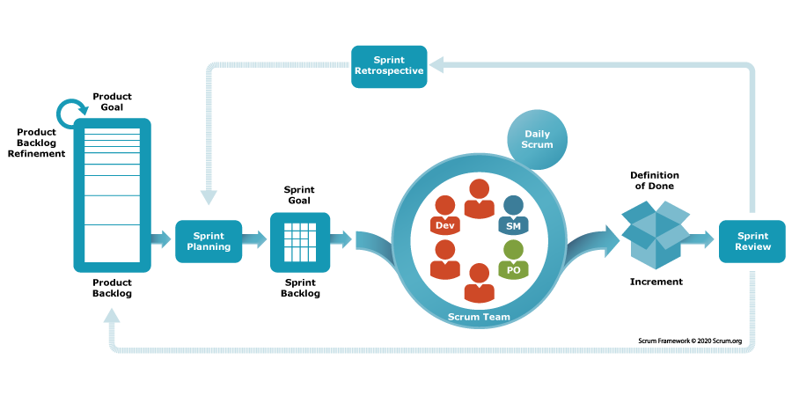

Figure 2 Scrum Process

## Tools and Technologies



Figure 3 Tools and Technologies Used

## Conceptual Diagram

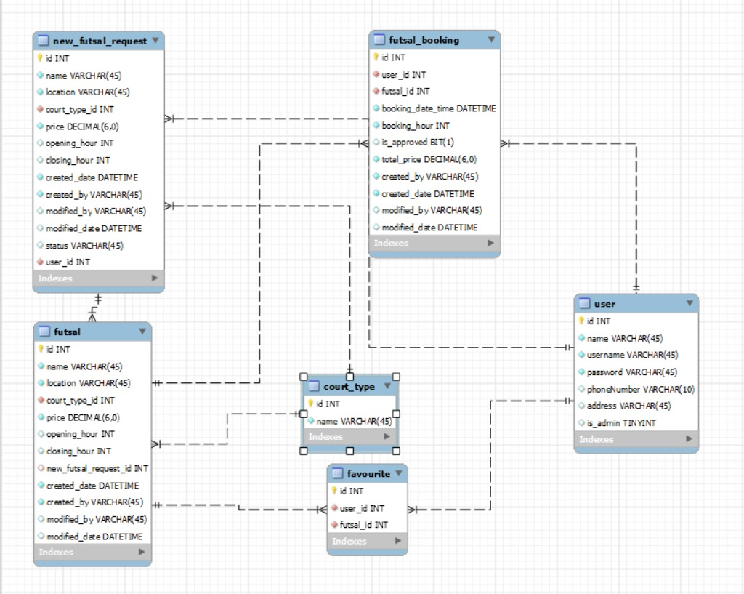

Figure 4 E-R Diagram of the Futsal Management System

# System Architecture

## Three Tier Architecture

Three-tier architecture is a client-server software architecture pattern in which the user interface (presentation), functional process logic ("business rules"), computer data storage and data access are developed and maintained as independent modules, on separate platforms. (Eckerson, 1995)

The purpose of this architecture is to improve modularity, maintainability, scalability, reliability and flexibility of the software system. The three layers are connected through well-defined interfaces, allowing each layer to function independently and enabling easy modification and maintenance of the application. The 3-Tier Architecture is a widely used design pattern for building scalable and maintainable software applications, and it is commonly used in web applications and enterprise software systems. (Matina, 2023)

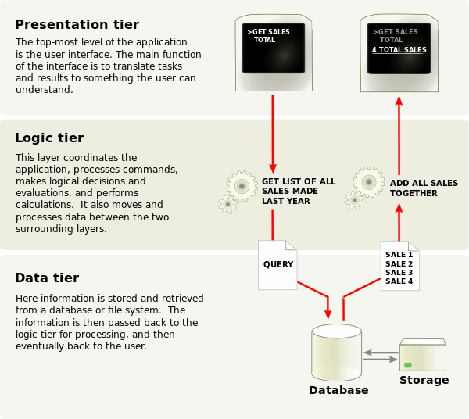

Figure 5 Three Tier Architecture

## MVC Pattern

MVC is an abbreviation that stands for Model, View, and Controller. MVC was conceived in 1978 as the design solution to a particular problem. The top level goal was to support the user's mental model of the relevant information space and to enable the user to inspect and edit this information (Reenskaug, 2003).

Later on, in 1988, the MVC paradigm was described in detail by Krasner and Pope in their article published in the Journal of Object-Oriented Programming. “Isolating functional units from each other as much as possible makes it easier for the application designer to understand and modify each particular unit without having to know everything about the other units.”

An application is divided into three main categories: the model of the main application domain, the presentation of data in that model and user interaction (Glenn E. Krasner, 1988). MVC pattern architecture is basically a three-layered architecture. It separates the characteristics of application.

**The Model**

The Model is the part of the system that manages all tasks related to data: validation, session state and control, data source structure (database). The Model greatly reduces the complexity of the code the developer needs to write (Altar & Pop, 2013) .

**The View**

The View layer controls the way data is displayed and how the user interacts with it. It also provides ways for data gathering from the users (Altar & Pop, 2013).

**The Controller**

The Controller binds all application logic and combines the display in the View with the functionality in the Model. It is responsible with data retrieval from the View and with establishing the execution path for the application. A Controller manages the relationship between a View and a Model. It responds to user requests, interacts with the Model and decides which View should be generated and displayed (Altar & Pop, 2013).

MVC pattern are used to define the location of all logic in application. MVC patterns provide the facility of parallel development. It means that every layer of the application are not dependent on each other i.e. three developer will work on the one layer of application. One developer will be working on user input logic (controller logic), other developer will be working on the user interface logic (view) and third developer will be working on the business logic (model) at the same time (Singh, 2020).

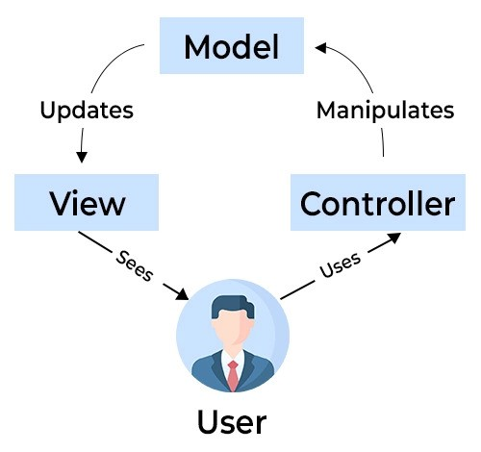

Figure 6 MVC Pattern

# Working Mechanism

1. User Registration and Profile Creation:

People start using the app by signing up. They make their own profiles with info like their name, email address and how to contact them.

1. Venue Discovery:

Utilizing a user-friendly interface, enthusiasts can explore a curated list of futsal venues based on location, amenities, and availability.

1. Booking Process:

Users select their desired futsal venue, check real-time availability, and proceed to book a slot using the intuitive booking system. The app provides a transparent overview of pricing and timings.

1. Favorites Feature:

Users have the option to mark and save their preferred futsal venues as favorites, creating a personalized list for quick access in the future.

1. User Communication:

The app facilitates clear and direct communication that allows users to receive booking confirmations, updates on their requests, and relevant information from the futsal facility.

1. Administrator Verification and Approval:

When a booking request is made, administrators receive prompt notifications and utilize efficient tools to verify and respond to requests, either accepting or rejecting them.

1. User History Tracking:

The app maintains a transparent and accessible booking history for users, allowing them to track and manage their futsal activities over time.

1. Venue Addition Workflow:

User can request the addition of new futsal venues to the app. Administrators review and approve these requests, ensuring a continuous expansion of the app's venue database.

# Project Plan

## Task Management

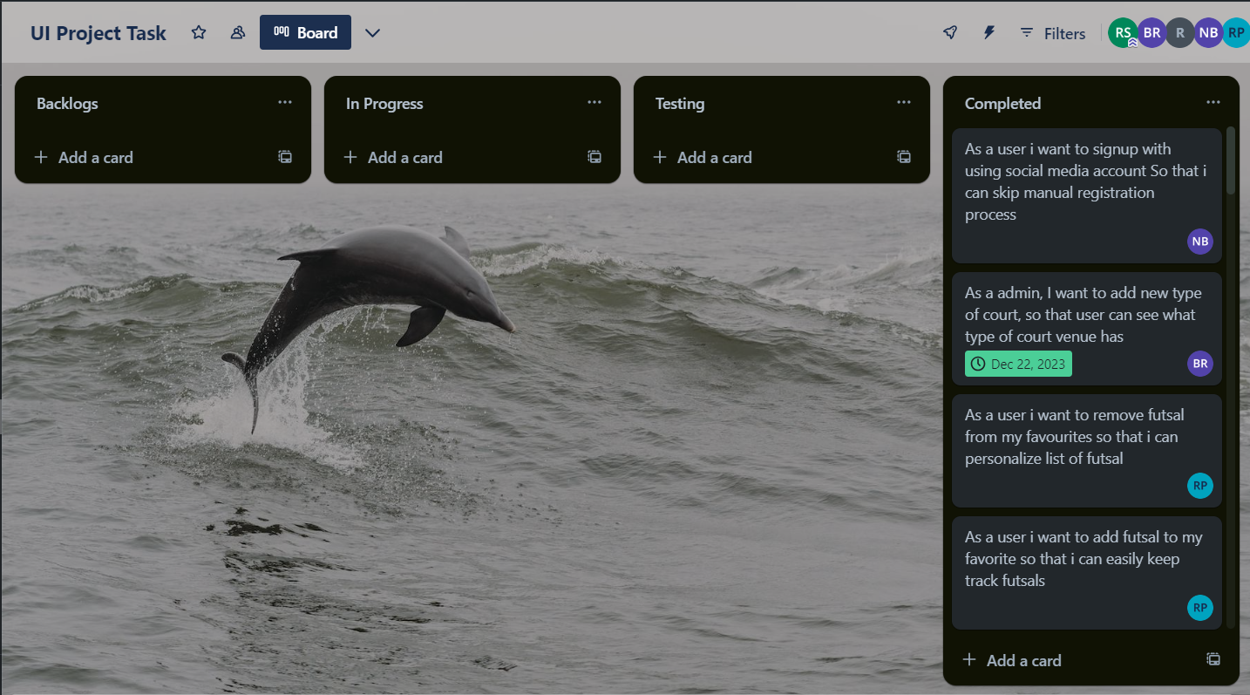Trello was used as a collaboration platform and task management as shown in figure below.

Figure 7 Trello of Futsal Management System

## Release Plan

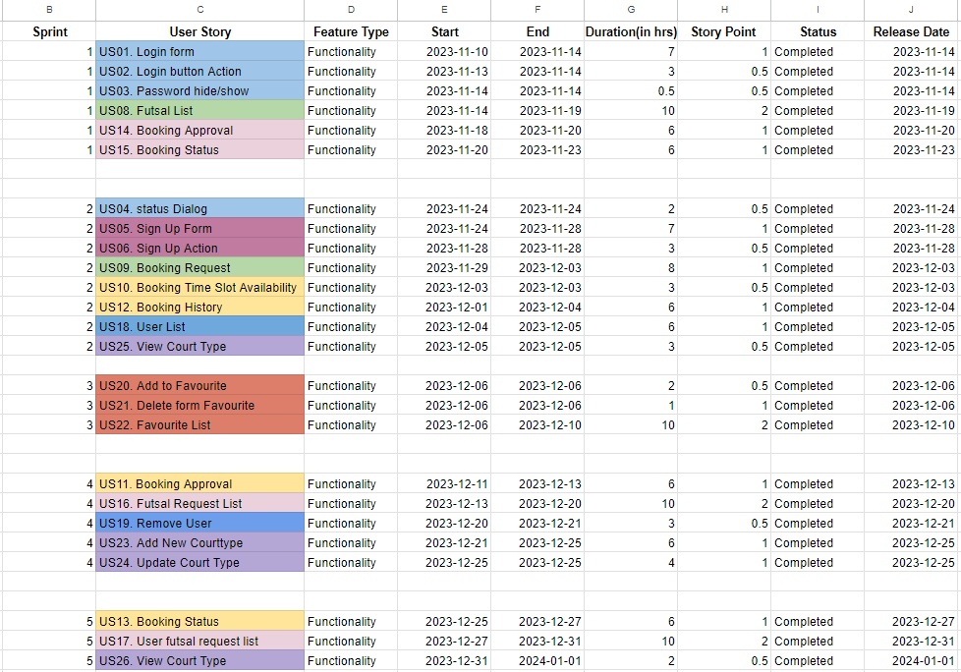

Figure 8 Release Plan of Futsal Management System

## Gantt chart

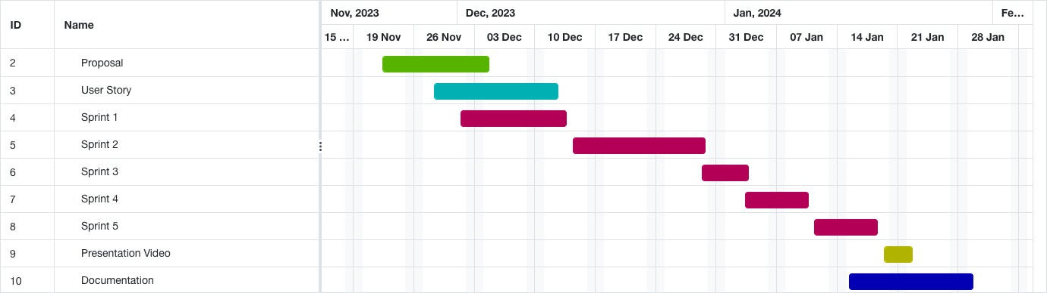

Figure 9 Gantt chart of Futsal Management System

# Prototype

## Low Fedility

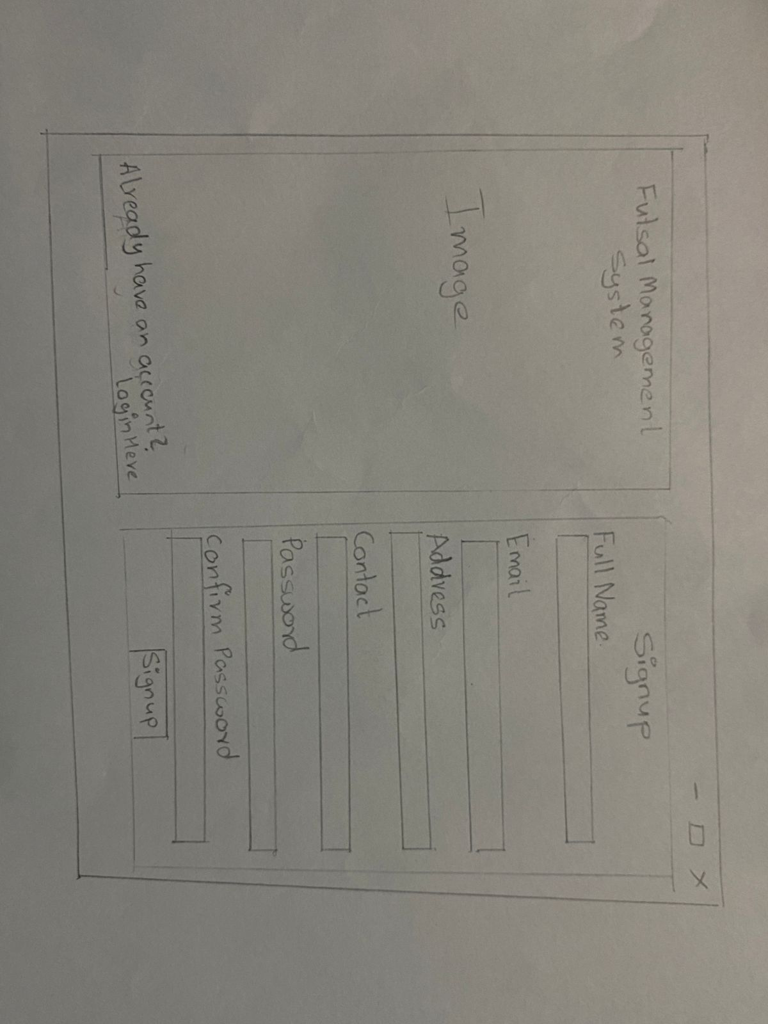

Figure 10 Register Screen

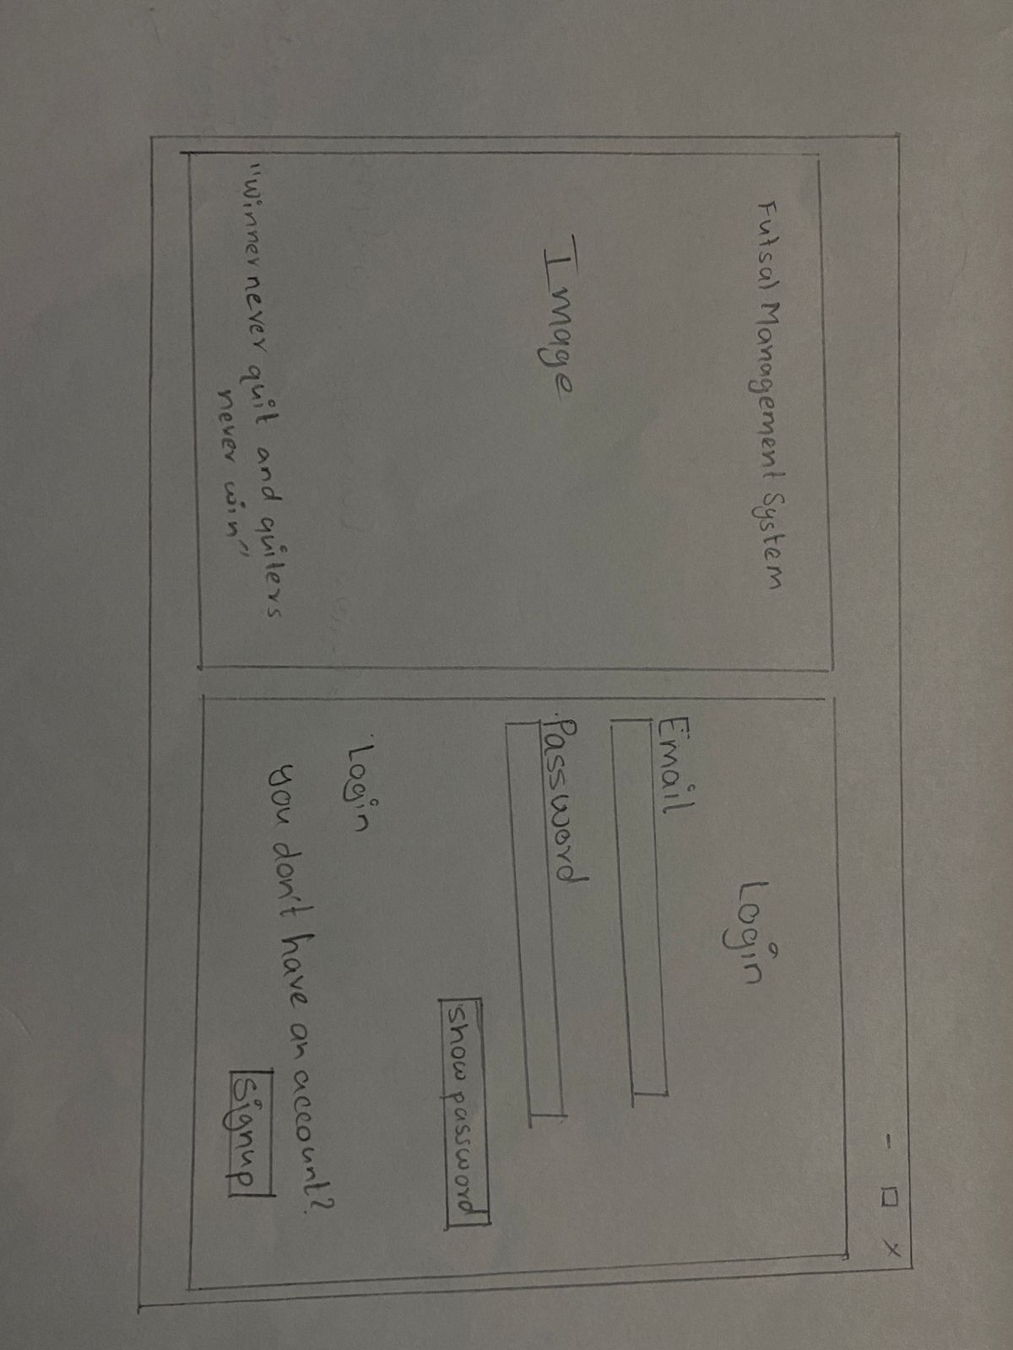

Figure 11 Login Screen

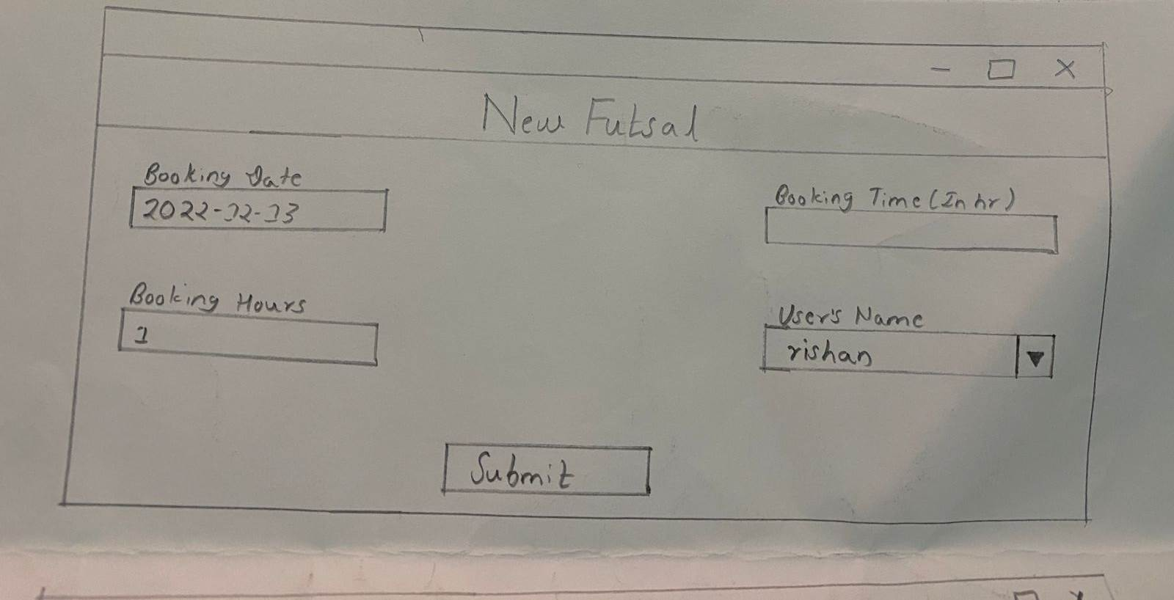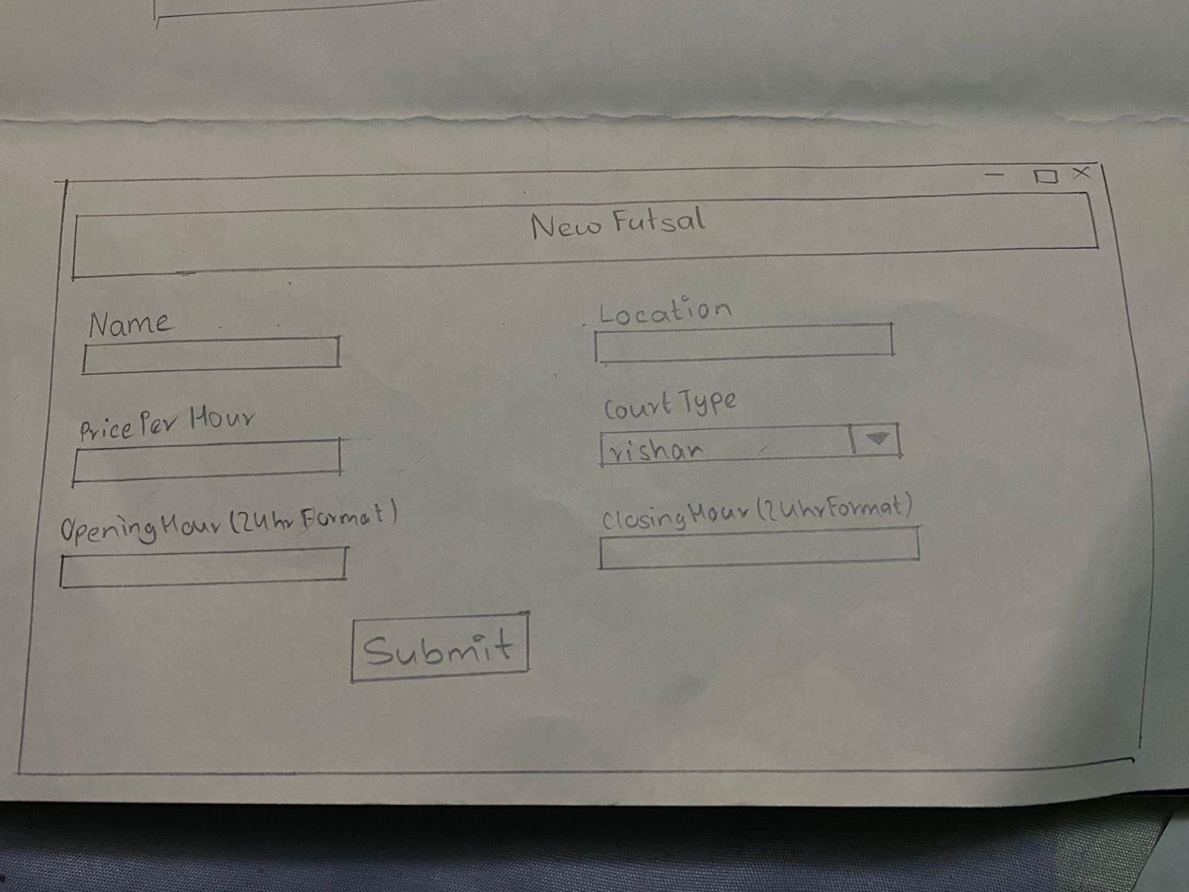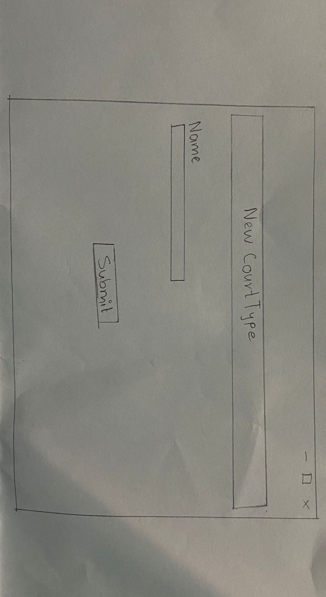

Figure 12 Futsal Book Screen

Figure 13 New Futsal Screen

Figure 14 New Court Type Screen

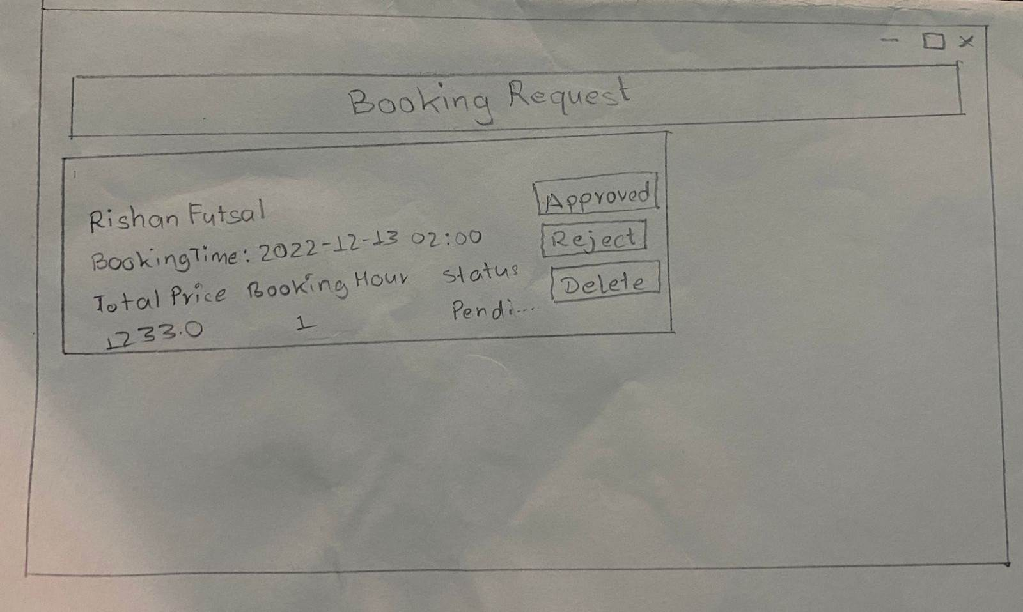

Figure 15 Booking Request Screen

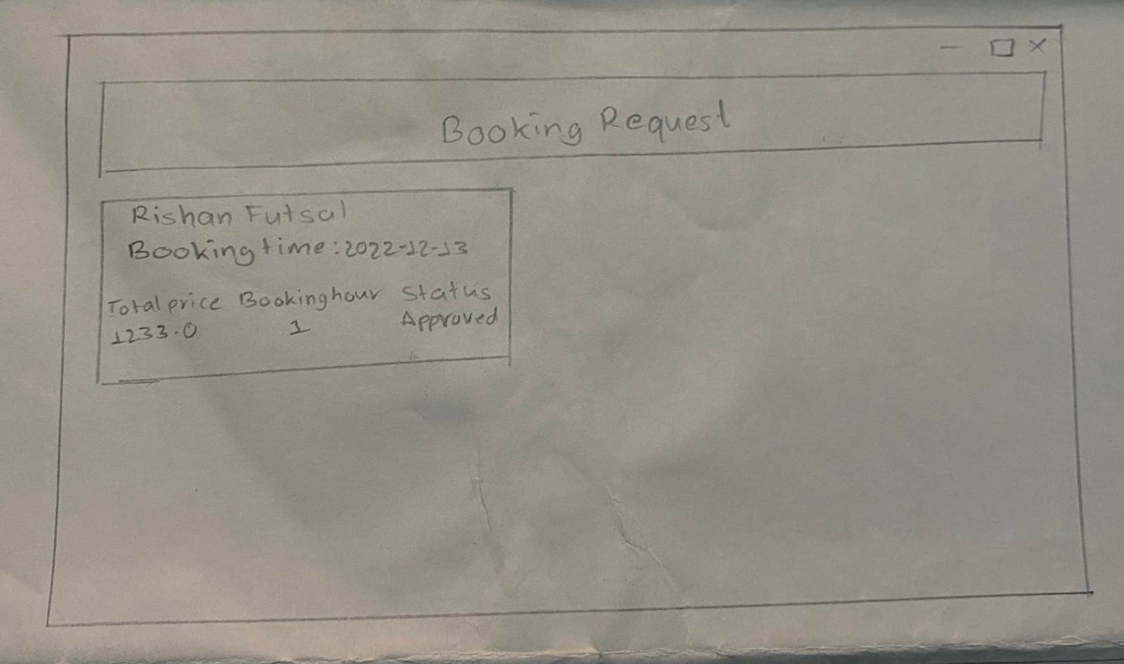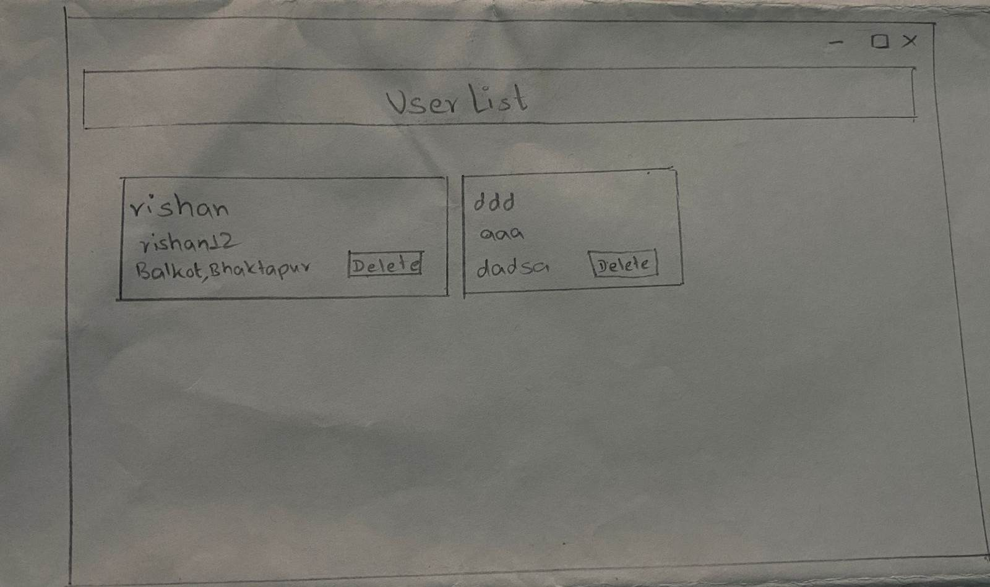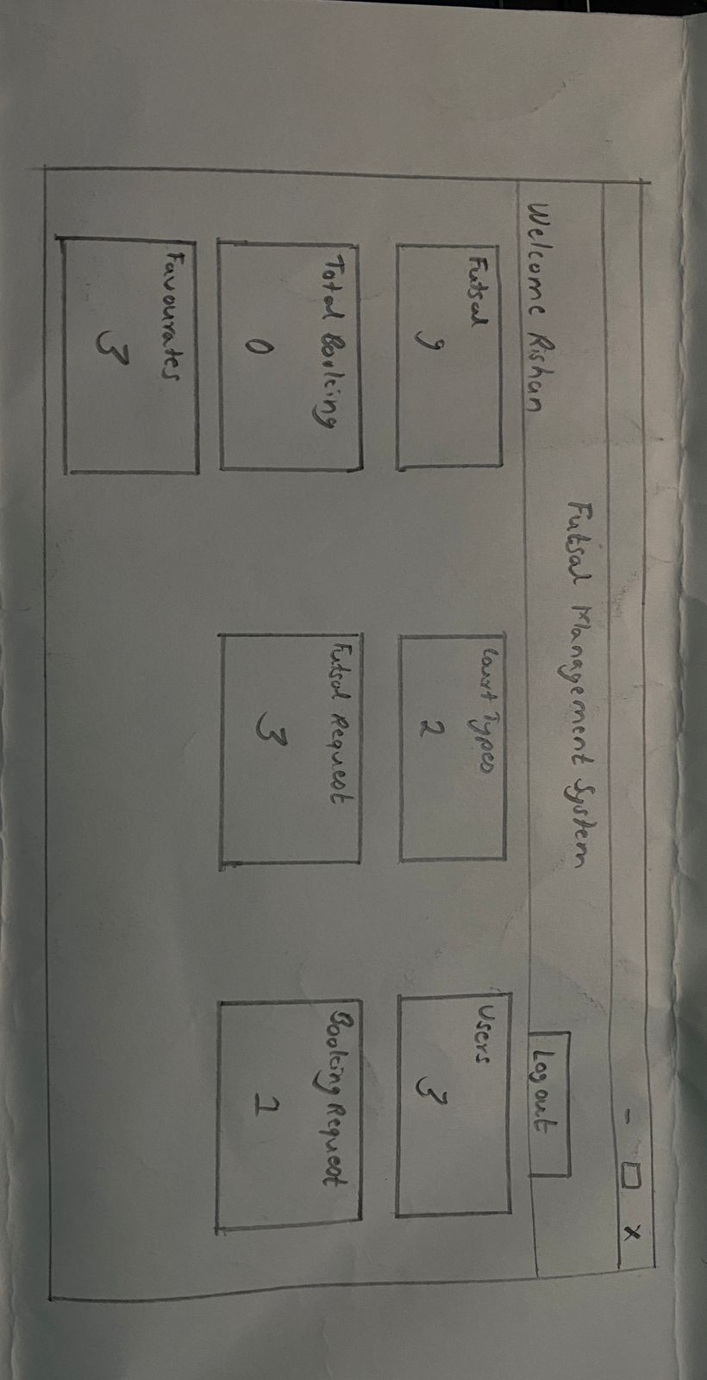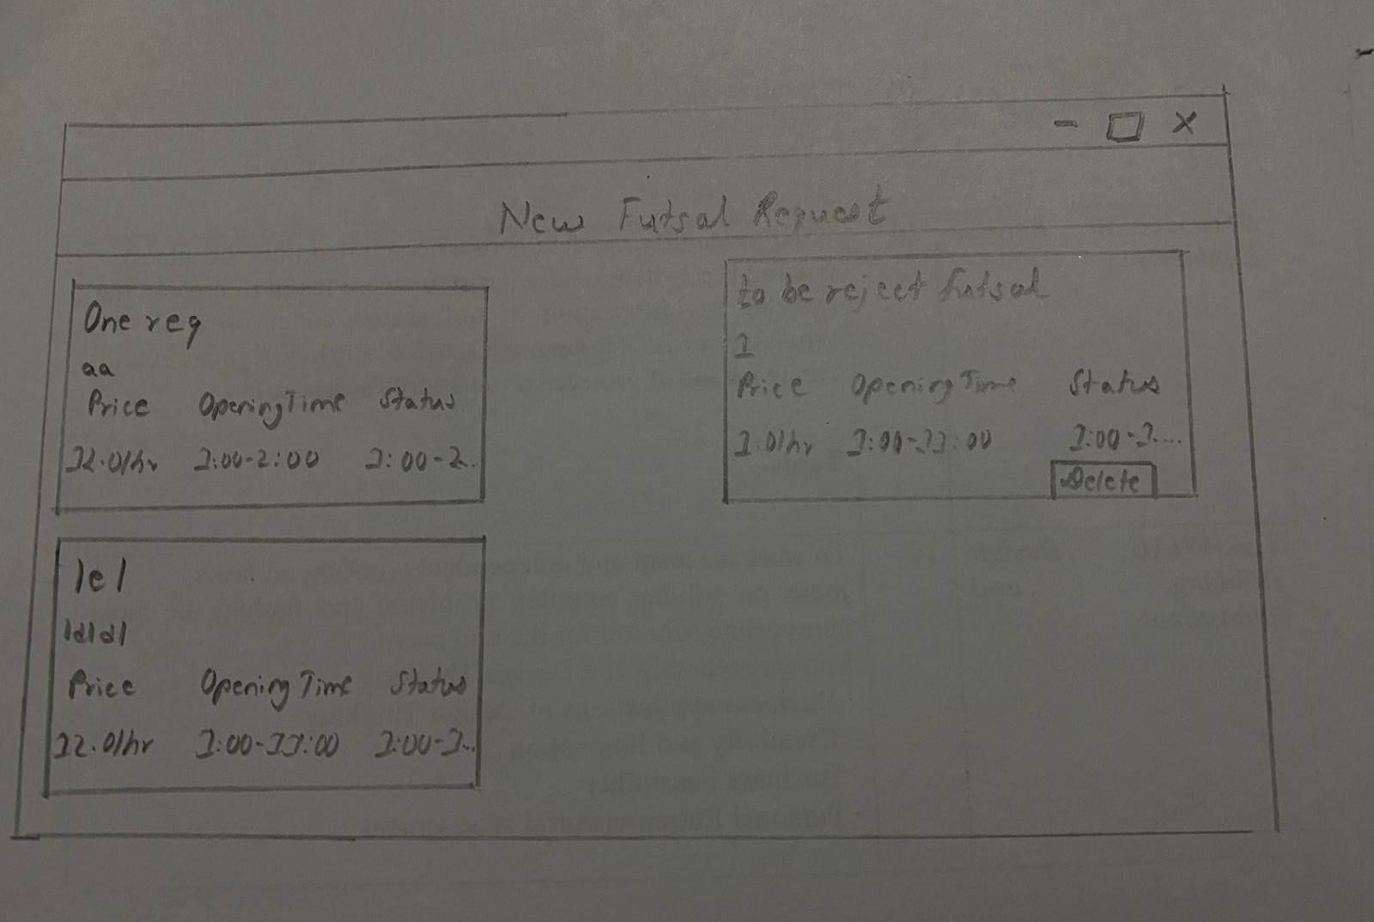

Figure 16 Booking Request List Screen

Figure 17 User List Screen

Figure 18 Dashboard Screen

Figure 19 New Futsal Request List Screen

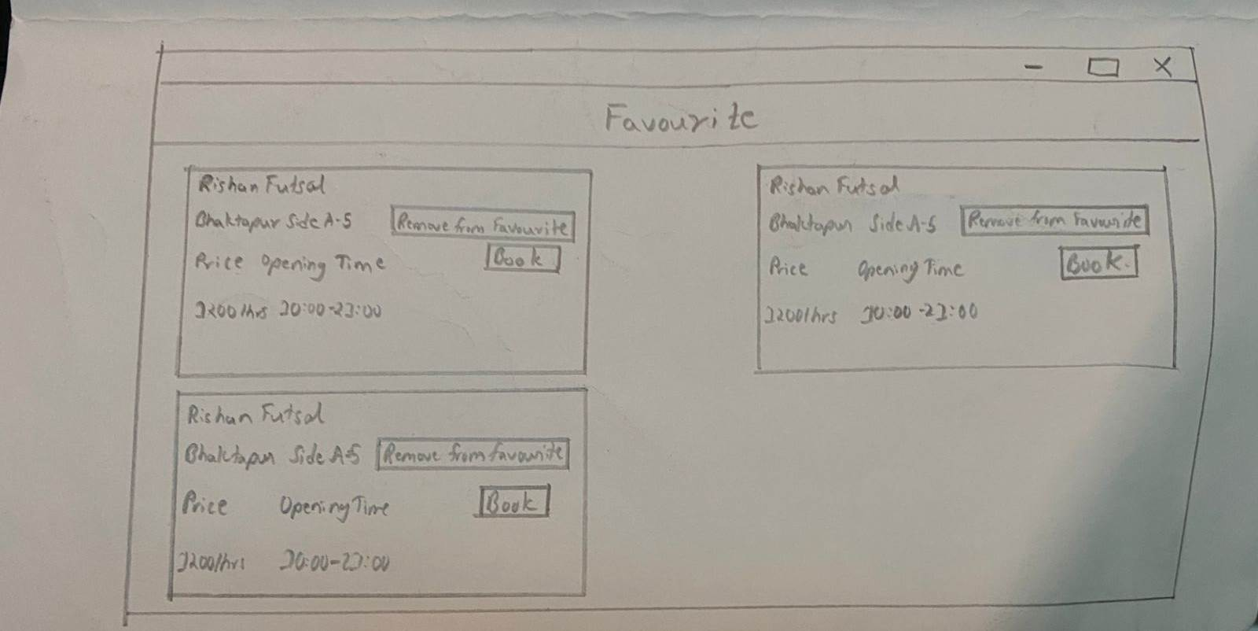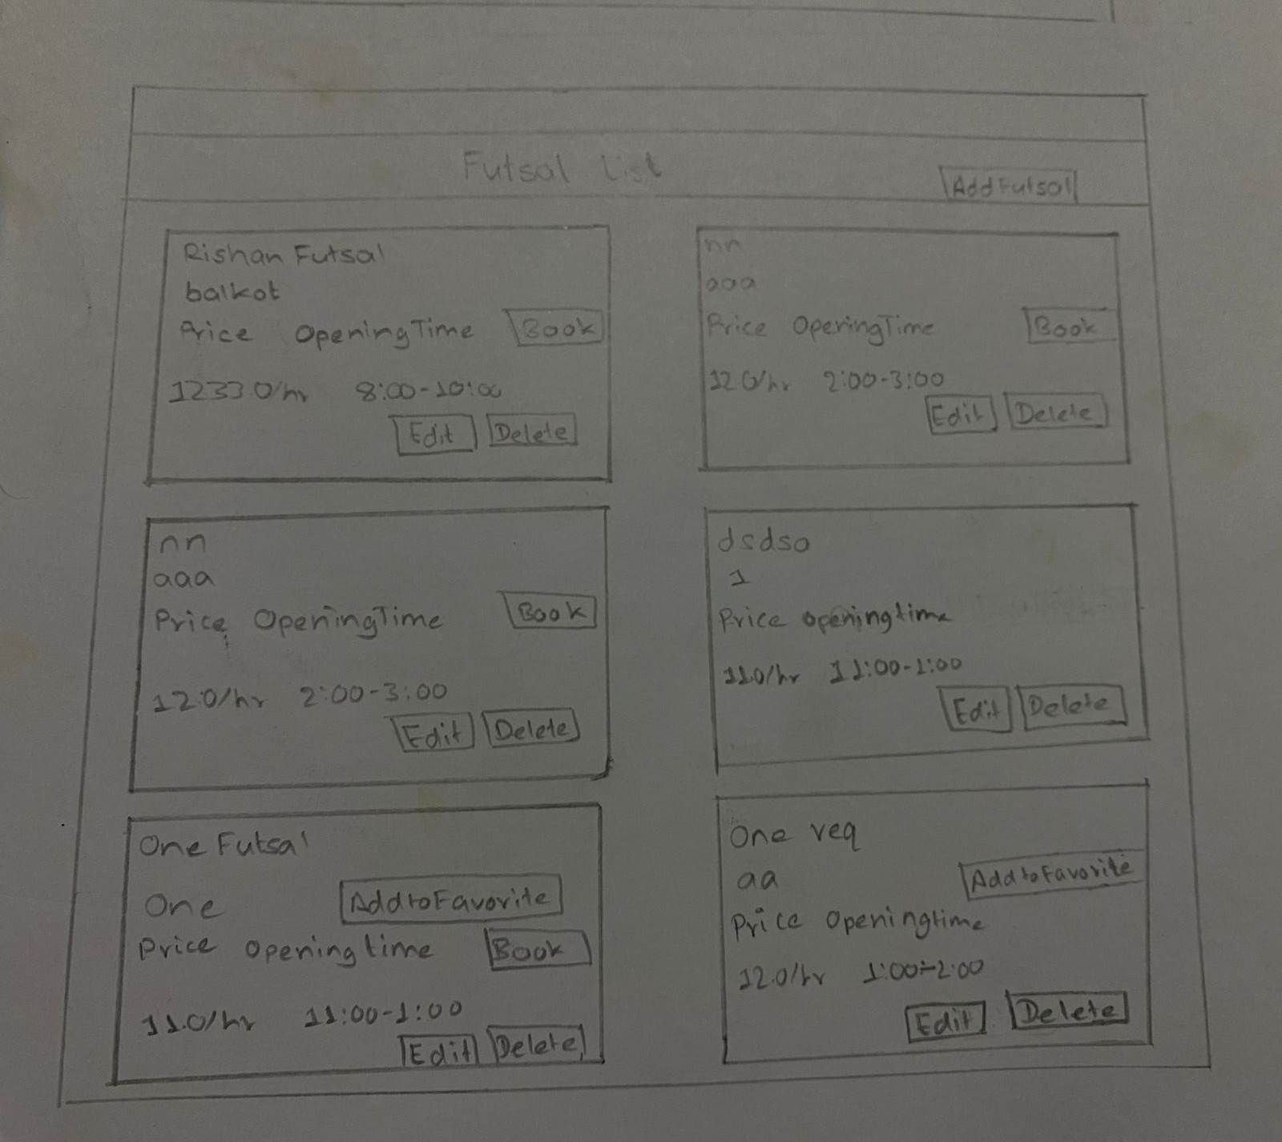

Figure 20 Favorite List Screen

Figure 21 Futsal List Screen

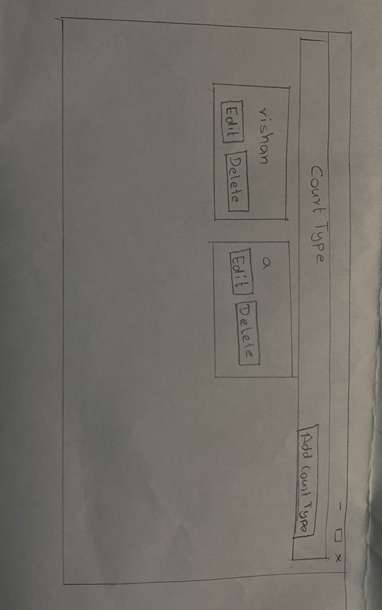

Figure 22 Court Type List Screen

## High Fedility

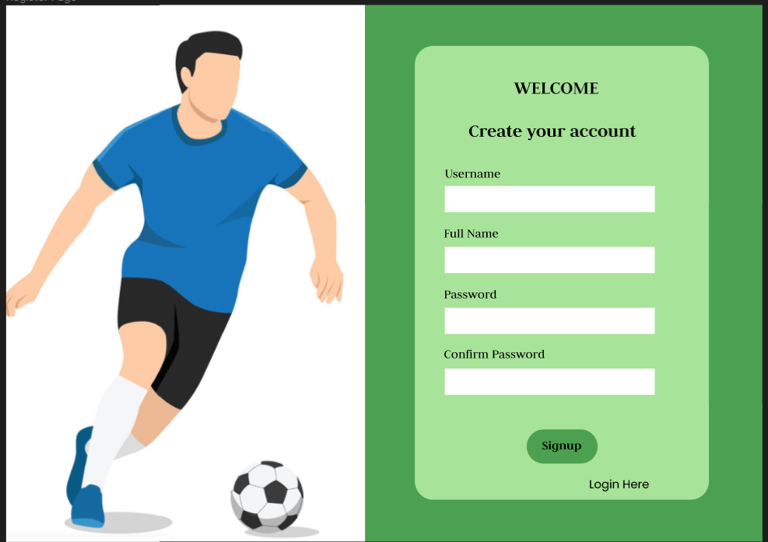

Figure 23 Register Screen

## 

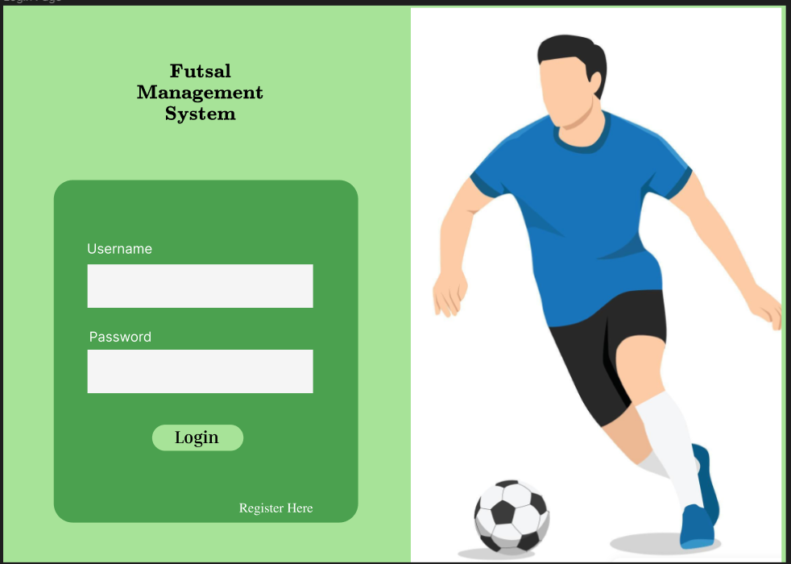

Figure 24 Login Screen

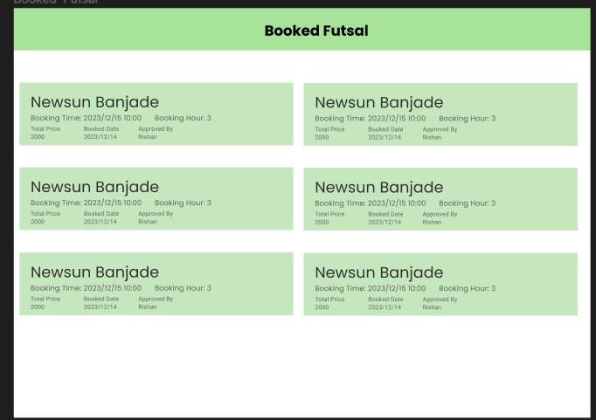

Figure 25 Booking List Screen

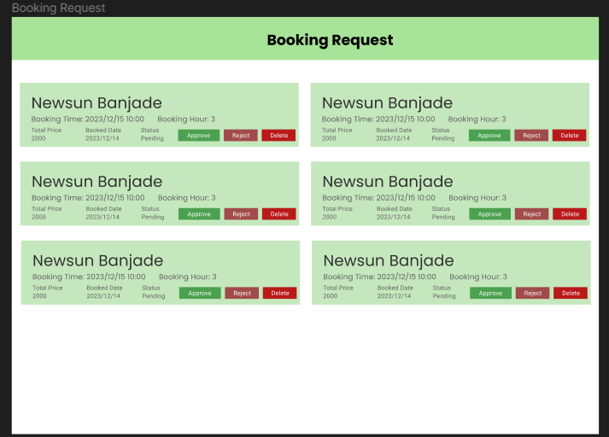

Figure 26 Booking Request List Screen

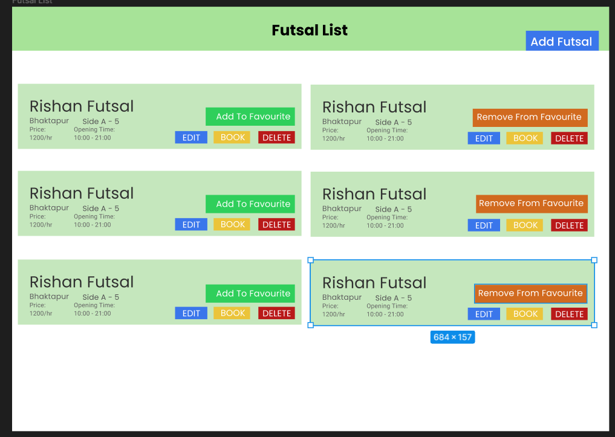

Figure 27 Futsal List Screen

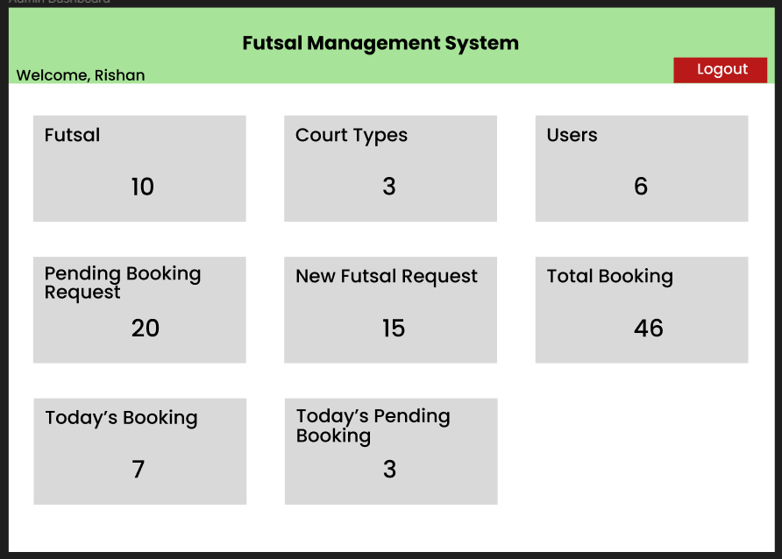

Figure 28 Dashboard Screen

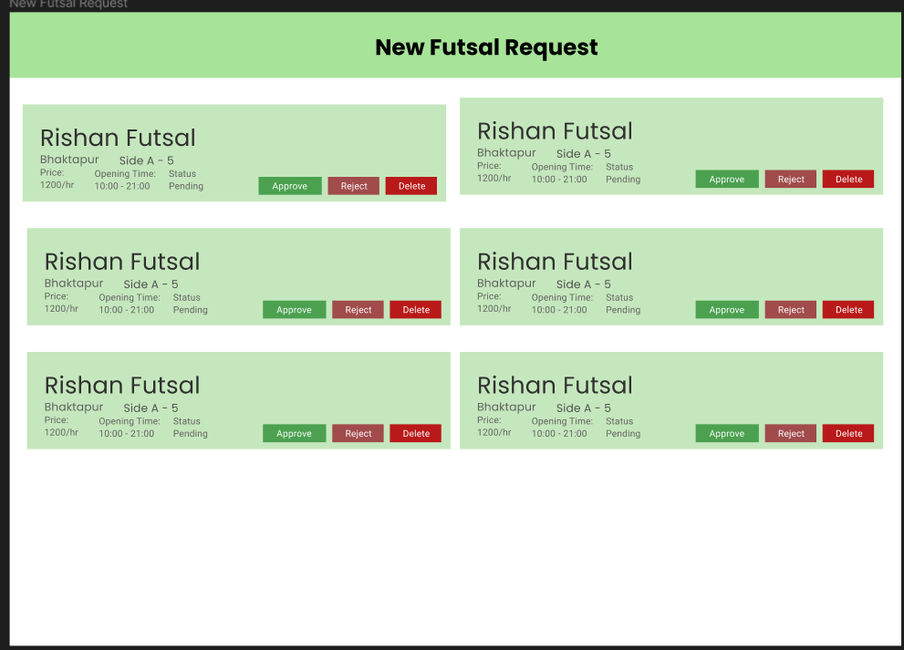

Figure 29 New Futsal Request List Screen

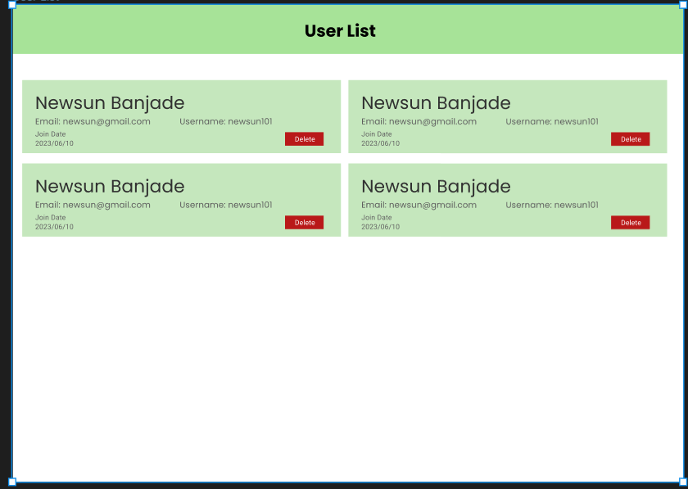

Figure 30 User List Screen

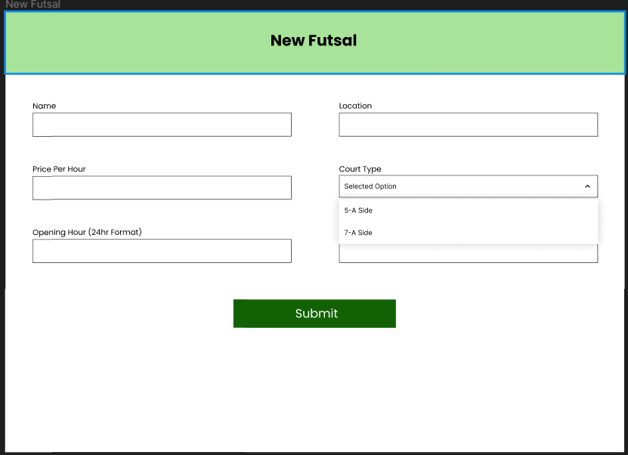

Figure 31 New Futsal Screen

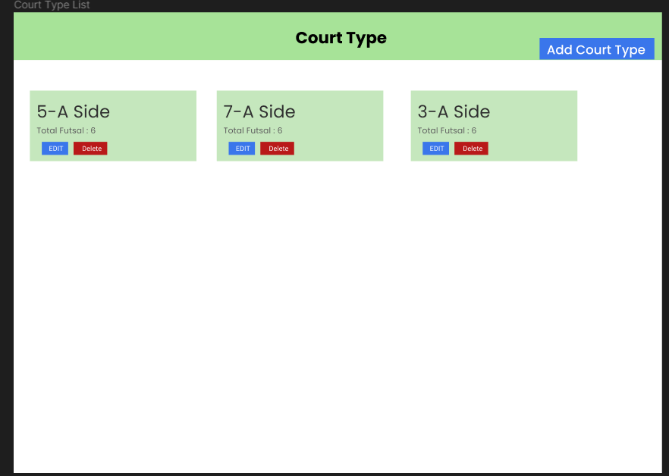

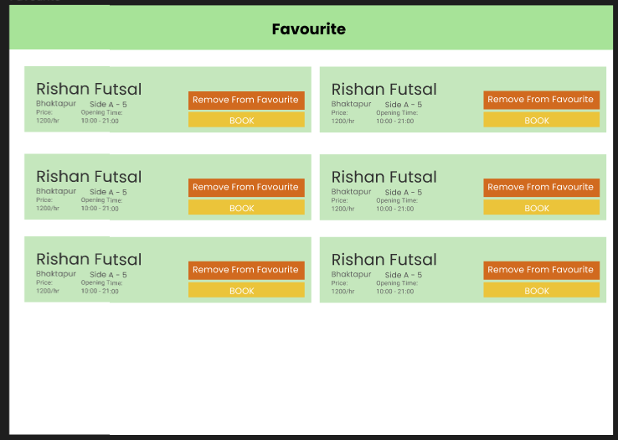Figure 33 Court Type List Screen

Figure 32 Favorite List Screen

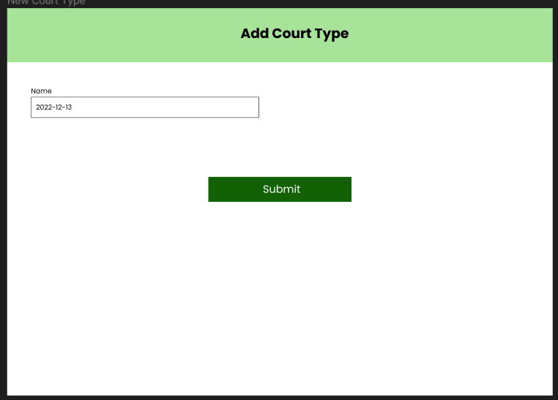

Figure 34 Add Court Type Screen

# Developed System

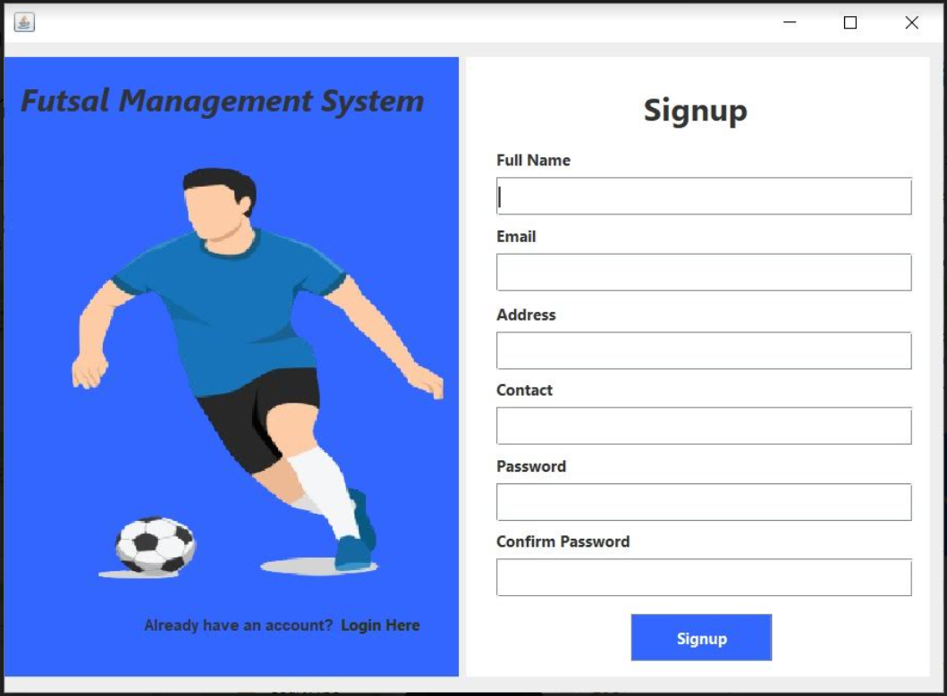

Figure 35 Register Screen

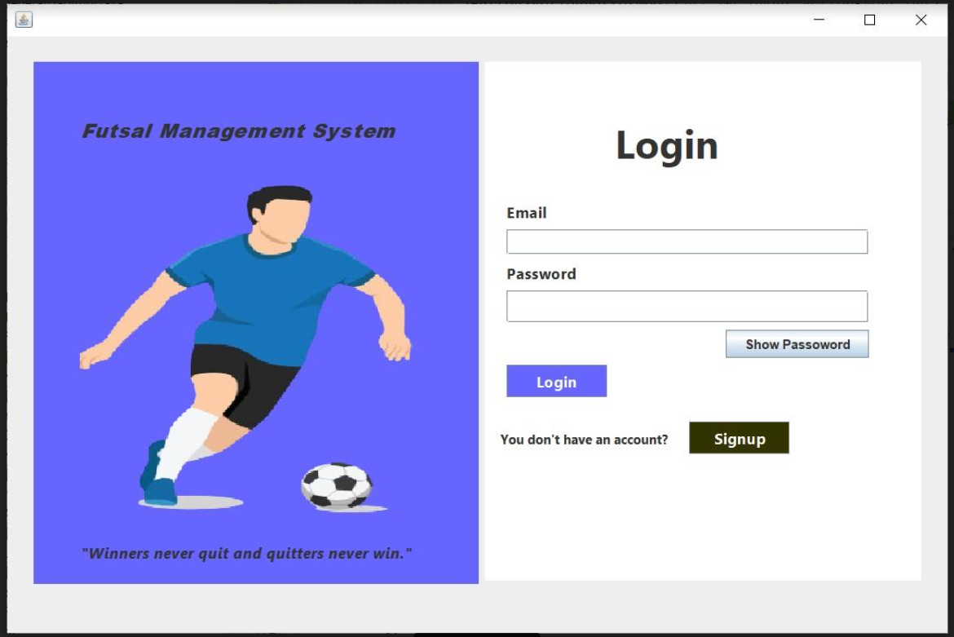

Figure 36 Login Screen

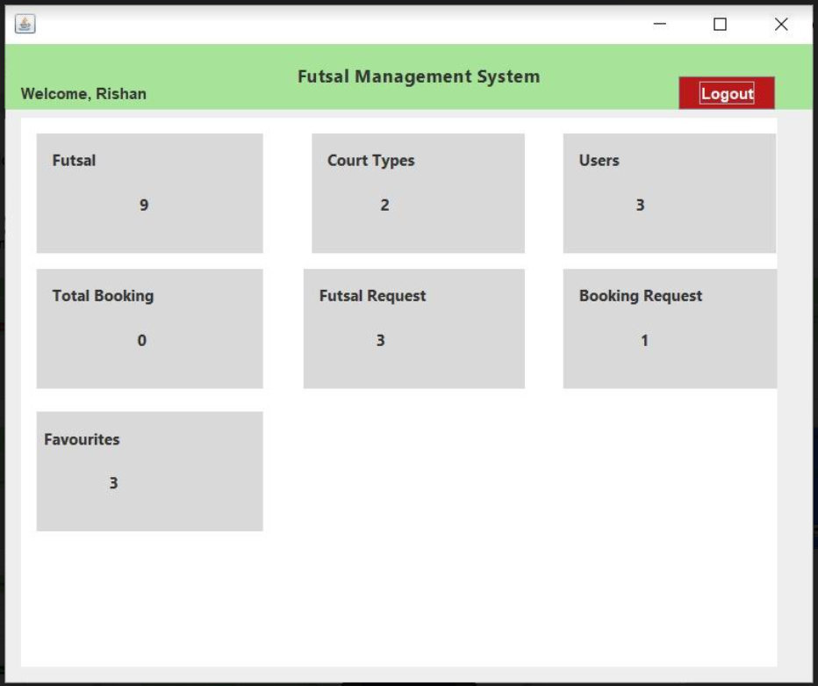

Figure 37 Dashboard Screen

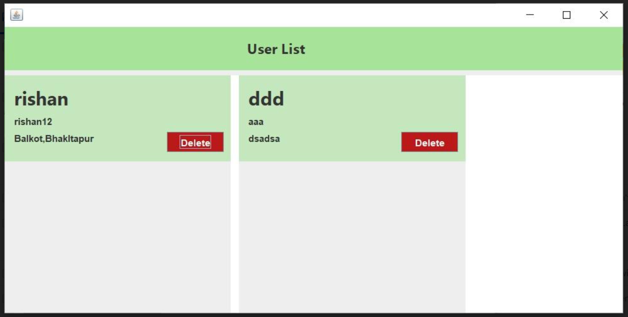

Figure 38 User List

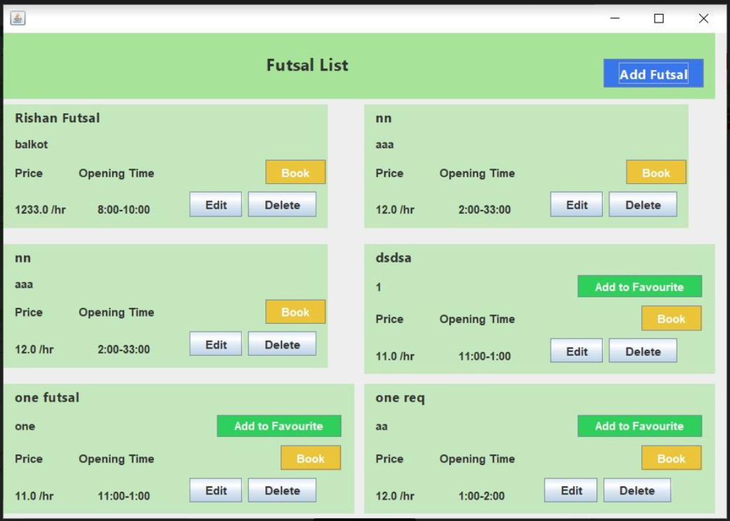

Figure 39 Futsal List Screen

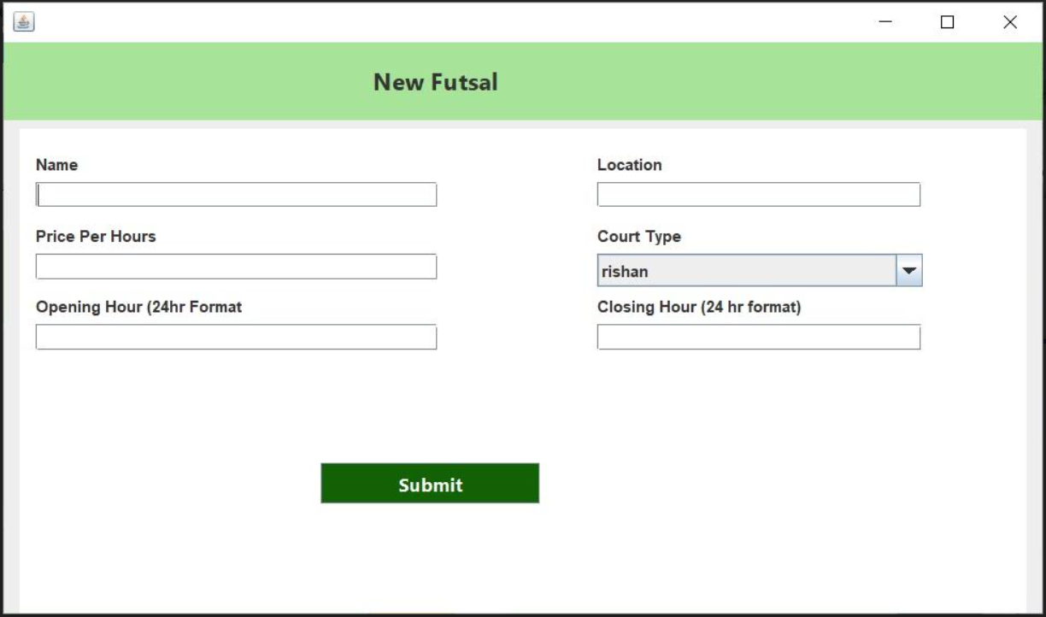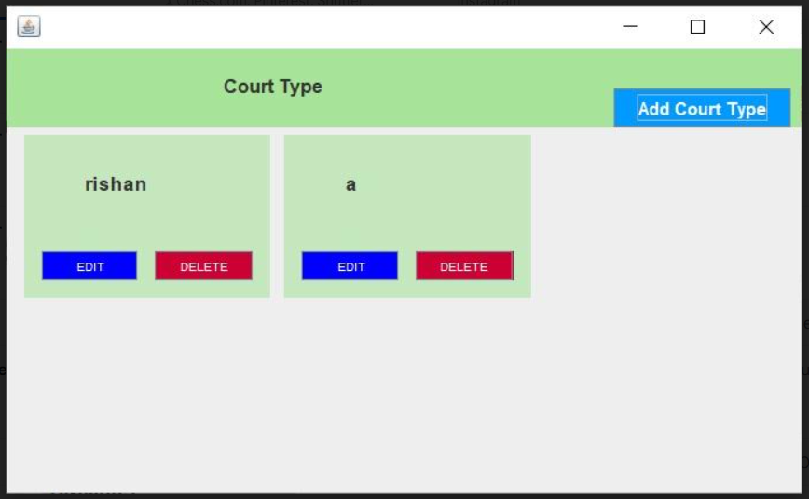

Figure 40 Court Type List Screen

Figure 41 New Futsal Screen

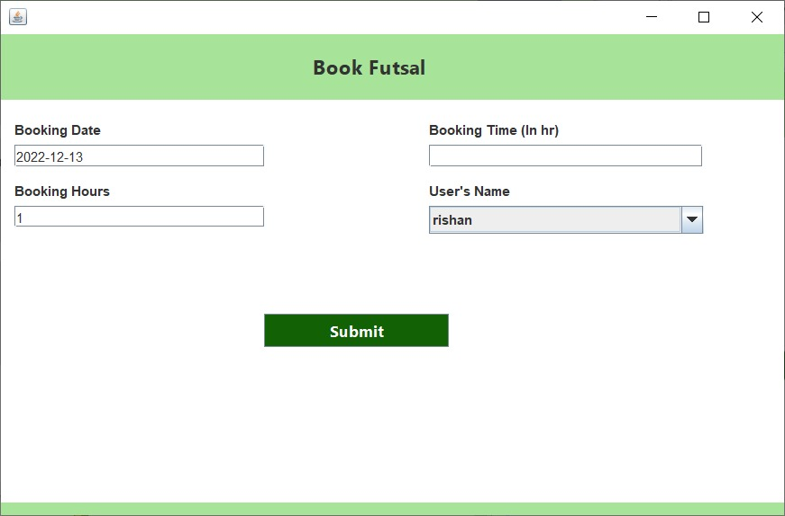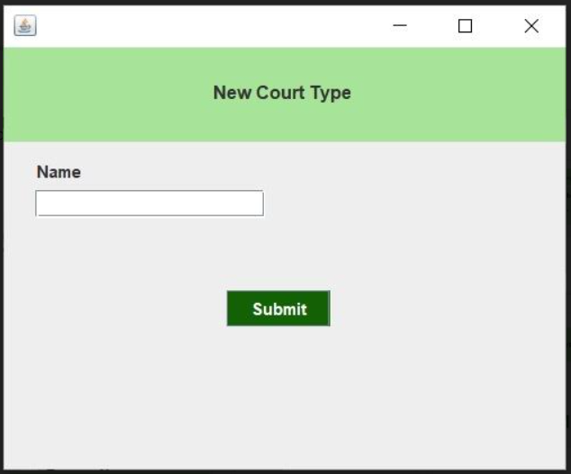

Figure 42 Book Futsal Screen

Figure 43 New Court Type Screen

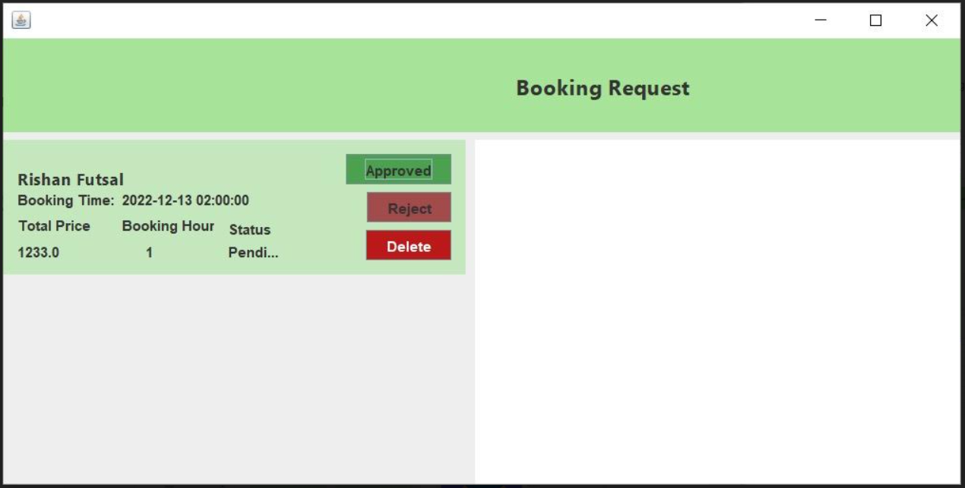

Figure 44 Futsal Booking Request Screen

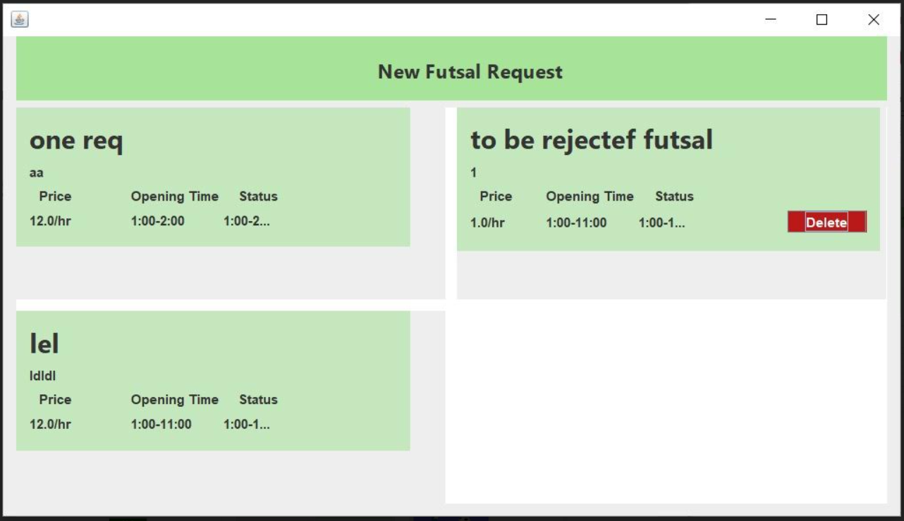

Figure 45 New Futsal Request Screen

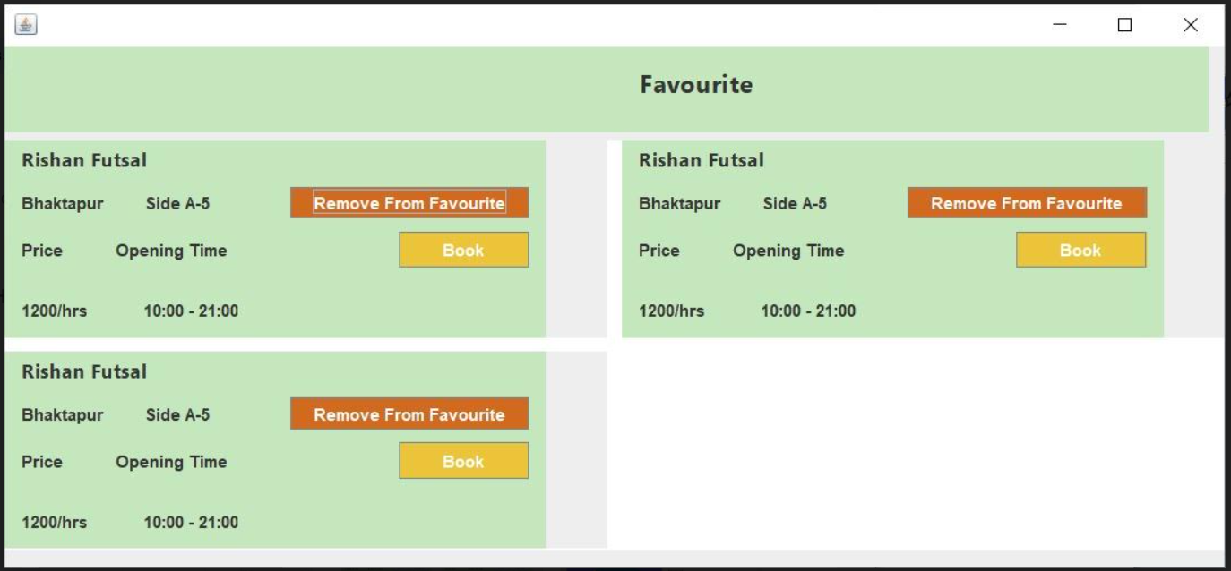

Figure 46 Favorites List Screen

# Outcome

## Sprint 1

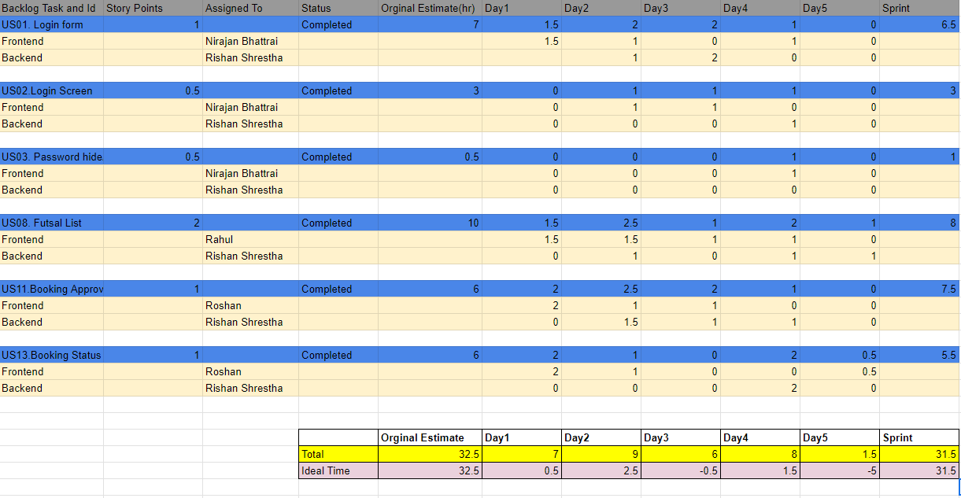

Figure 47 Backlog of Sprint 1

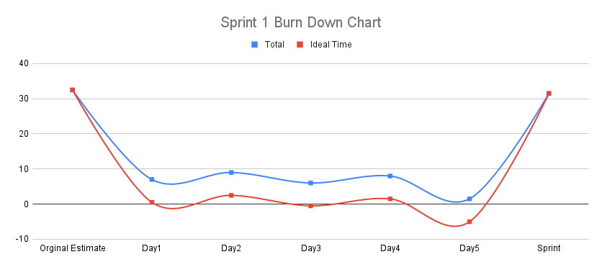

Figure 48 Burn down Chart of Sprint 1

## Sprint 2

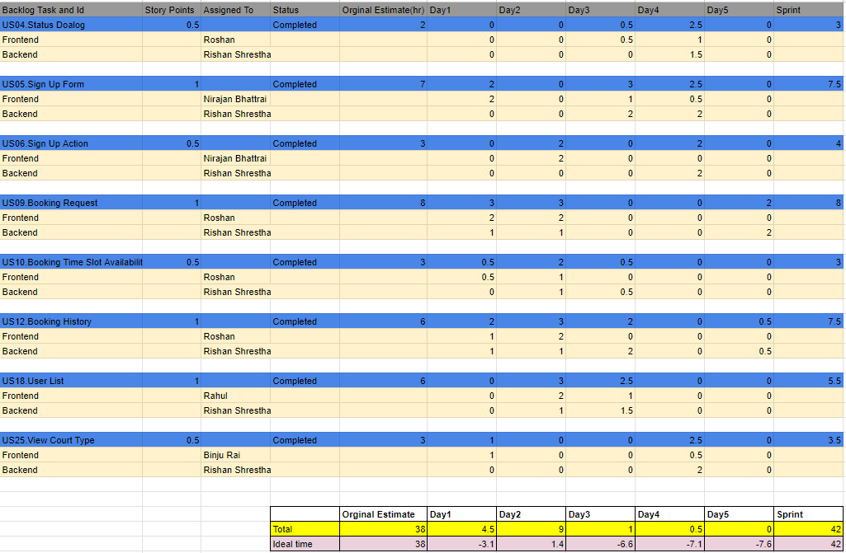

Figure 49 Backlog of Sprint 2

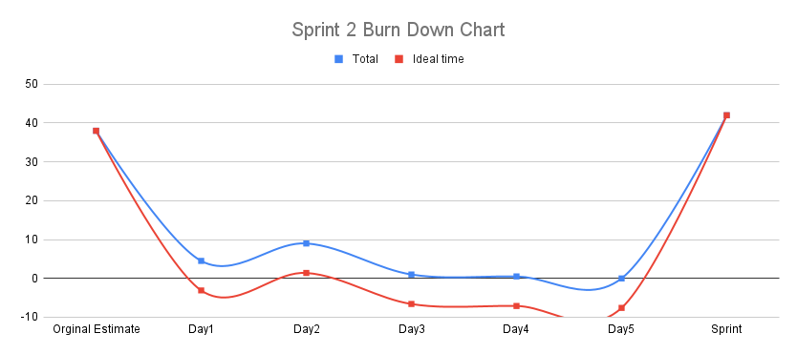

Figure 50 Burn down chart of Sprint 2

## Sprint 3

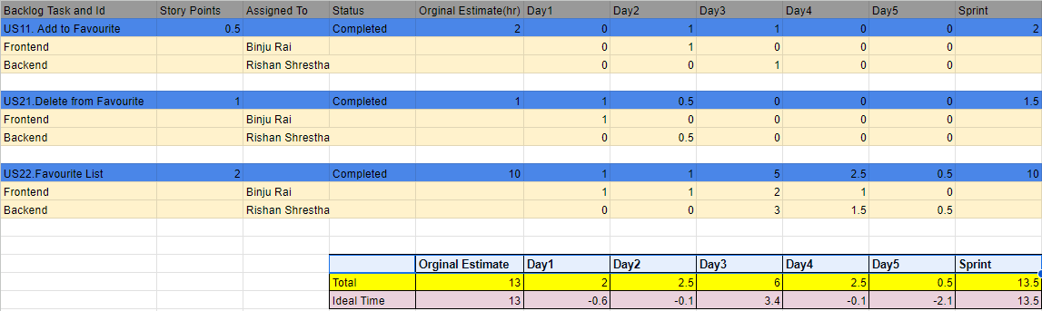

Figure 51 Backlog of Sprint 3

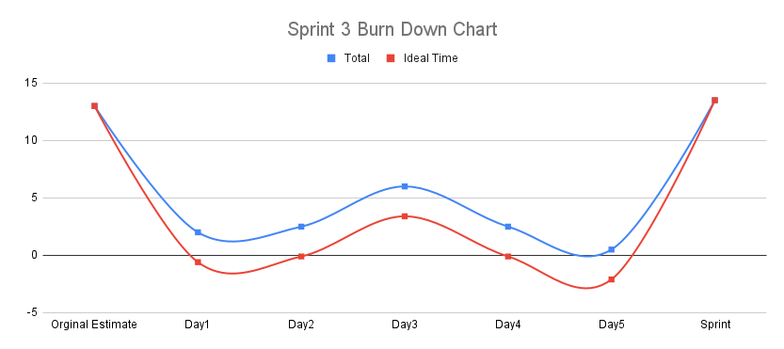

Figure 52 Burn down chart of Sprint 3

## Sprint 4

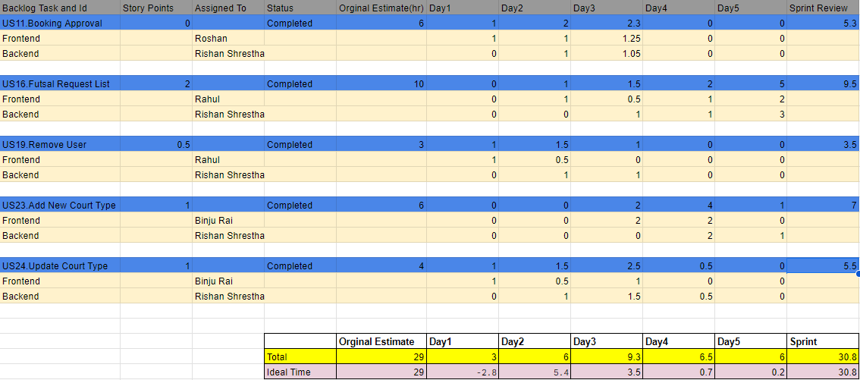

Figure 53 Backlog of Sprint 4

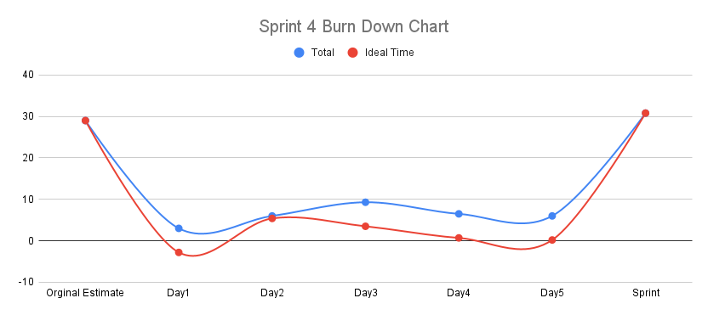

Figure 54 Burn down chart of Sprint 4

## Sprint 5

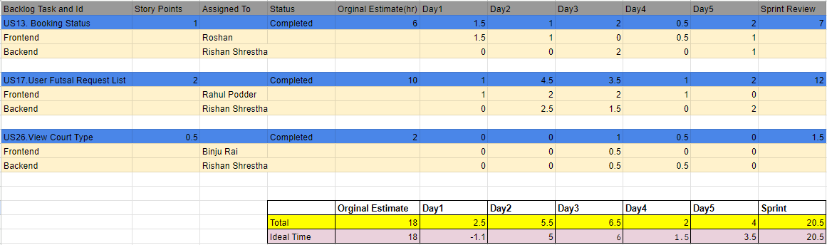

Figure 55 Backlog of Sprint 5

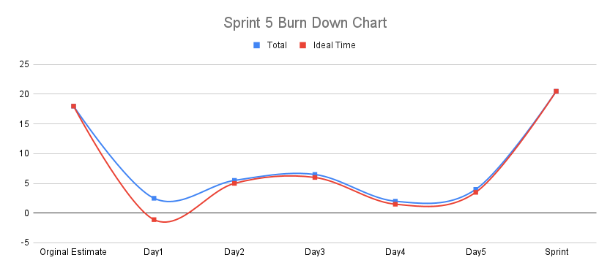

Figure 56 Burn down chart of Sprint 5

# Testing

Figure 57 Register Test

Figure 58 Login Test

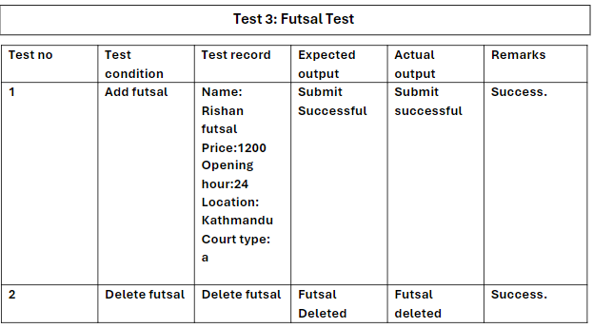

Figure 59 Futsal Test

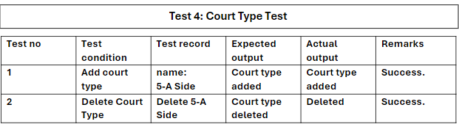

Figure 60 Court-type Test

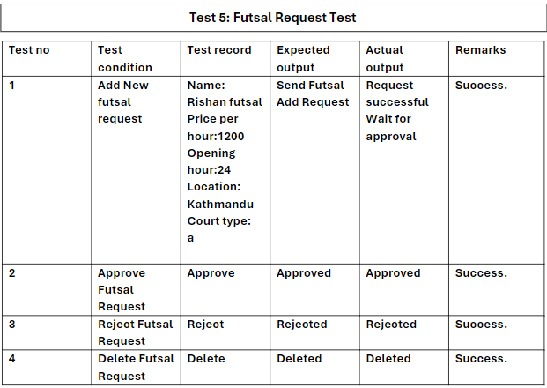

Figure 61 Futsal Request Test

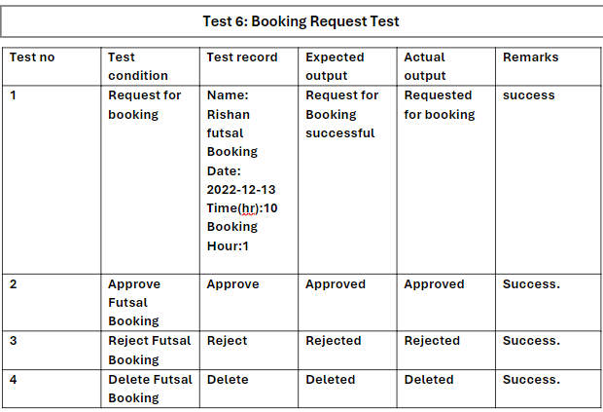

Figure 62 Booking Request Test

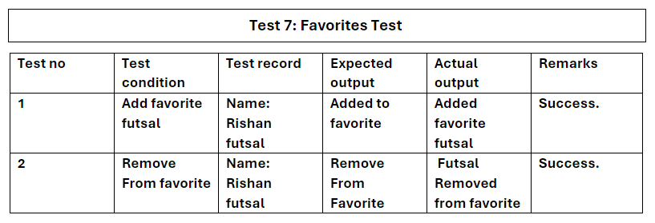

Figure 63 Favorite Test

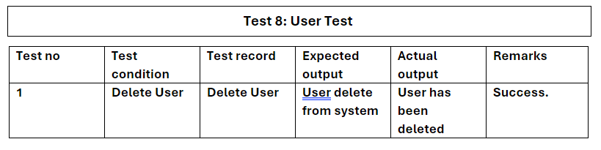

Figure 64 User Test

# Conclusion

In conclusion, the Futsal Management App stands as a pioneering solution that redefines the futsal experience for enthusiasts and administrators alike. With a user-friendly interface, efficient booking processes, and transparent communication channels, the app empowers users to seamlessly discover, book, and manage their preferred futsal venues. The incorporation of innovative features such as availability updates, favorites, and a comprehensive booking history enhances user satisfaction and convenience. Administrators benefit from robust tools for streamlined verification, approval workflows, and user management, ensuring operational efficiency. The app's scalability, adaptability, and commitment to user feedback underscore its dedication to continuous improvement. As the Futsal Management App bridges the gap between passion and efficiency, it aspires to become the go-to platform for futsal enthusiasts and administrators, fostering a vibrant and cohesive community where the love for the sport thrives effortlessly.

# SWOT Analysis

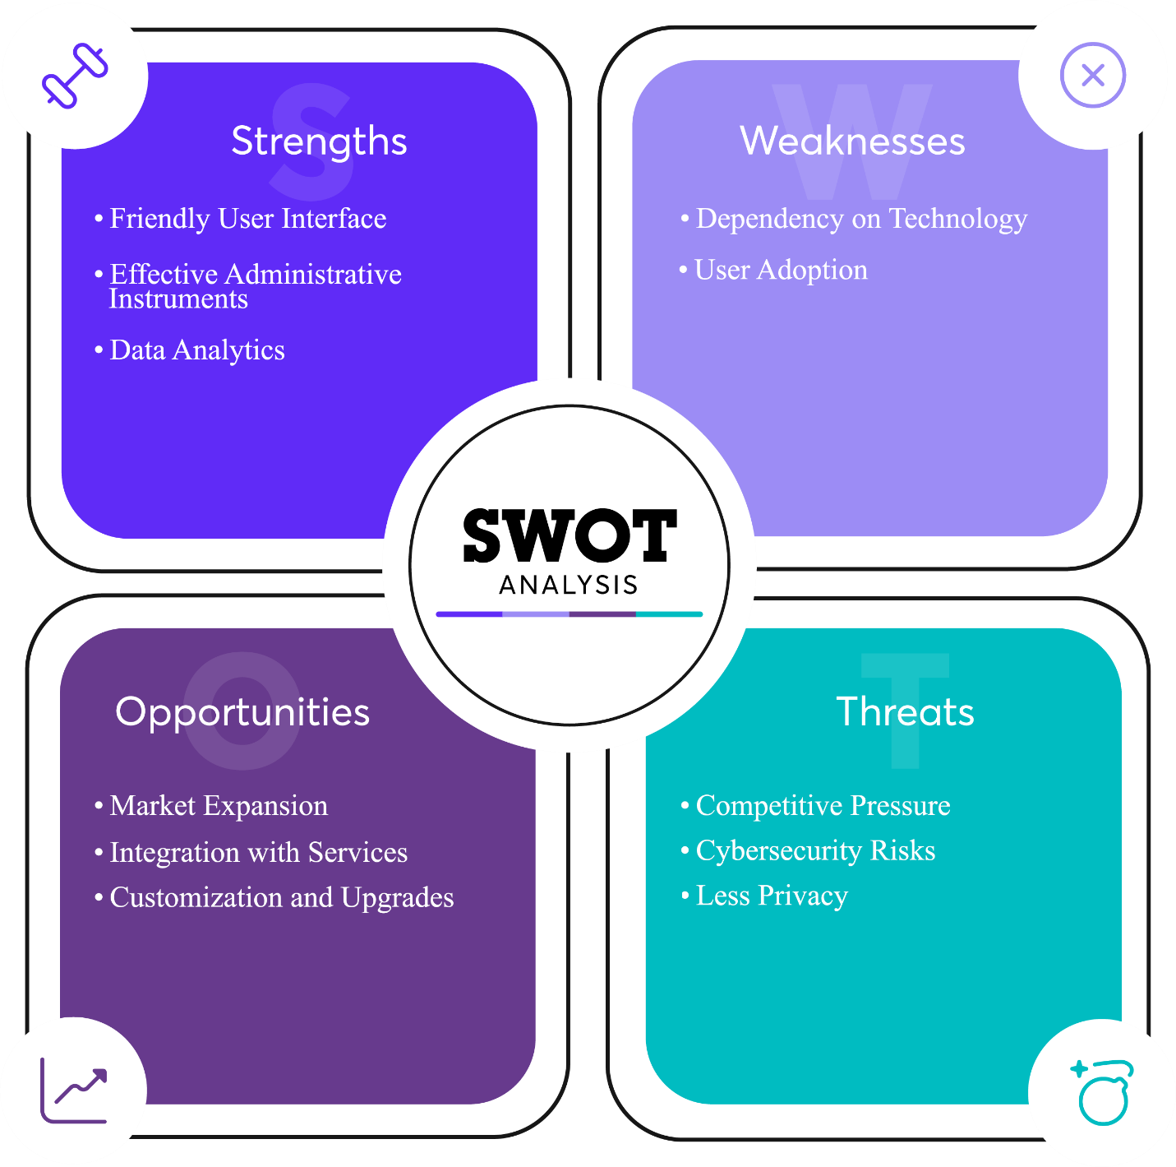

Figure 65 SWOT Analysis

# Appendix

## Version Control (GitHub):

GitHub is used as version control, enabling history tracking, and the ability to revert to previous states and as well as for team-collaboration. The repository link is as follows: <https://github.com/Rishan99/Semester2Project>

## Prototype (Figma):

Design can be viewed at: <https://www.figma.com/file/uegNhnahr5aEmYxj9sxAK1/Futsal-Management>

## Project Artifacts:

We used google sheets to list-out the task and record the time required to complete them, and also to record the sprint progress. Sheet can be accessed through: <https://docs.google.com/spreadsheets/d/1ZpeS8viHfYg70q3FK98XdUfIkQW_3sVq6gALemLSeBQ>

Trello was used for better workflow visualization using boards and prioritization of task and as a collaboration platform. It can be accessed through: <https://trello.com/b/Weyf6zmz/ui-project-task>

## YouTube:

Working Mechanism and detailed working of system is described in video available at: <https://www.youtube.com/watch?v=6TWJaFD6R2s&ab_channel=MasterStudy>

# References

Altar, A., & Pop, D.-P. (2013). Designing an MVC Model for Rapid Web Application Development. *24th DAAAM International Symposium on Intelligent Manufacturing and Automation*, 1172-1179.

Darrell Rigby, J. S. (2016, May). Retrieved from Harvard Business Review: https://hbr.org/2016/05/embracing-agile

Eckerson, W. W. (1995). *Three Tier Client/Server Architecture: Achieving Scalability, Performance, and Efficiency in Client Server Applications.*

Glenn E. Krasner, S. T. (1988). A cookbook for using the model-view controller user interface paradigm in Smalltalk-80. *Journal of Object Oriented Programming, 1*(3), 26-49.

javatpoint. (n.d.). Retrieved from https://www.javatpoint.com/software-engineering-agile-model

Kolade, C. (2022, June 21). *FreeCodeCamp*. Retrieved from MVC in Computer Science – The MVC Model: https://www.freecodecamp.org/news/what-does-mvc-mean-in-computer-science/?fbclid=IwAR1CGl7Dp0dmXcK6erh5dRfqKRIk-gSKx5i3D-QIhjXlxSRDF4Ek6hlWwDY

Matina, S. (2023, May 1). *What is the 3-Tier Architecture?* Retrieved from Medium: https://medium.com/@shrestha.matina.20/what-is-the-3-tier-architecture-4520522e0720

Reenskaug, T. (2003). The Model-View-Controller (MVC) Its Past and Present. *Journal in Computer Science*, 10-12.

Sharma, S. &. (2021). Challenges and Opportunities in Mobile App Development for Sports Booking 10(6), 321-325. *International Journal of Engineering and Advanced Technology*, 321-325.

Sharma, S., Gupta, D., & Sarkar, D. (2012). Agile Processes and Methodologies: A Conceptual Study. *International Journal on Computer Science and Engineering 4(5), 4*(5), 892-895.

Singh, A. &. (2022). A Comparative Analysis of Popular Futsal Booking Apps. *International Journal of Mobile Computing and Telematics*, 54-62.

Singh, S. (2020). MVC Framework: A Modern Web Application Development. *International Research Journal of Engineering and Technology (IRJET), 7*(1), 51-53.

Zhang, Y. G. (2022). A Survey of Mobile Apps for Booking Sports Facilities. *Journal of Sports Science and Medicine*, 523-532.